What is happening to the Mother during the 2nd Trimester?
(Week 15 to week 27)
Definition
Signs and Symptoms
Health and Nutrition
Medical Issues
Complications

Fetal Development weeks 15 to 27
Week | Size | Major changes in outside formation and structures | Major changes on inside organs and structures
15 | Apple  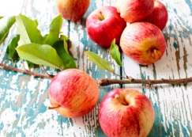
16 | Avocado  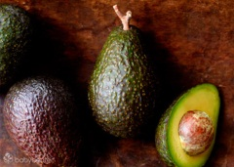
17 | Turnip  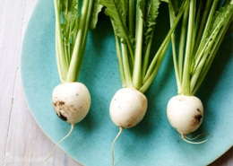
18 | Bell Pepper  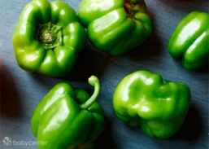
19 | Heirloom Tomato  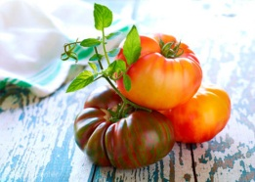
20 | Banana  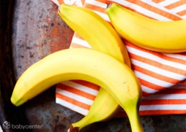
21 | Carrot  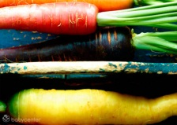
22 | Spaghetti Squash  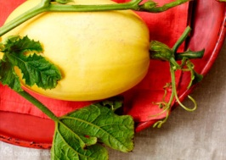
23 | Mango  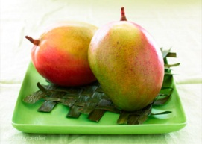
24 | Corn  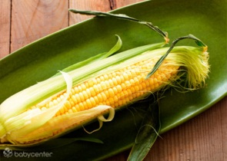
25 | Rutabago  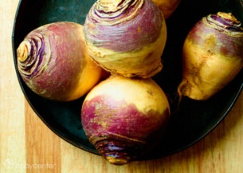
26 | Green Onion  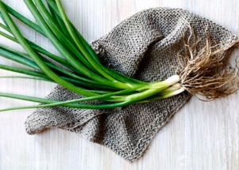
27 | Cauliflower  