What is happening to the Mother during the 1st Trimester?
(Conception to week 14)
Definition
Signs and Symptoms
Health and Nutrition
Medical Issues
Complications

Fetal Development weeks 4 to 14
Week | Size | Major changes in outside formation and structures | Major changes on inside organs and structures
4 | Poppy seed  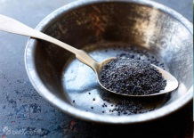
5 | Sesame seed  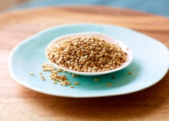
6 | Lentil  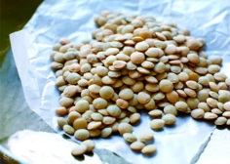
7 | Blueberry  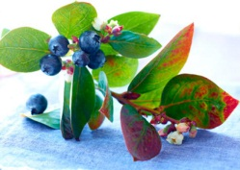
8 | Kidney bean  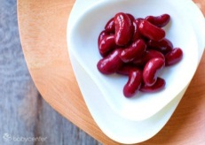
9 | Small grape  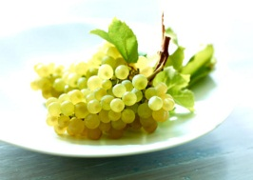
10 | Kumquat  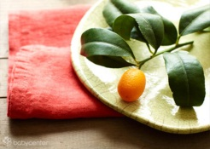
11 | Fig  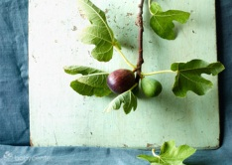
12 | Lime  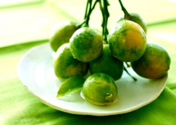
13 | Pea Pod  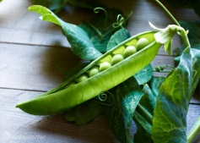
14 | Lemon  