Using a Rotary Cutter Properly and Safely
- Always make sure you are using a “self-healing” rotary cutting mat
- Make sure the safety latch is always one when not using it (even if it is just for a second)
- Use a Rotary cutting ruler – not any other ruler
- Line up the ruler with where you want your material cut
- Press straight down on the handle of the rotary cutter – never cut with the blade on an angle
- Hold on to the ruler with your fingers away from the cutting edge and apply pressure so the ruler will not slip
- Apply even pressure using your forearm and shoulder and cut in a forward motion
- Never cut toward yourself
For accurate cutting line up the lines from the mat with a fresh cut edge of your fabric. Use the lines (which are 1 inch by 1 inch) to ensure your fabric is cut the same width.
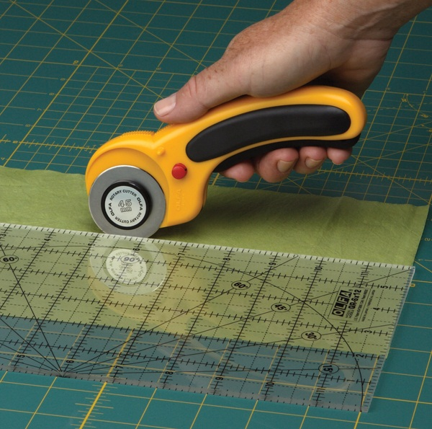
- Keep your rotary cutter pressed against the ruler
- Use even pressure from your forearm and shoulder
- Hold the ruler stable with you other hand (keeping fingers away
- Cut away from your body
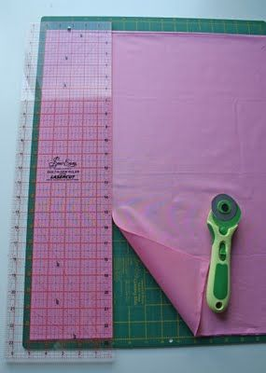
- Line up your fabric with a straight line on the mat and cut. This will create a straight edge to work from
- Then choose how wide you want your strip to be and line up the ruler against the edge of your cut fabric.
  - Make sure you have the same width all the way along, check your markings
- Cut straight and away from you
- To then cut the width, take your strip and line it up on a line from your cutting mat
- Again take your ruler and decide how wide you want your square, rectangle, etc. Cut straight and away from you

