Thread a needle and knot the end – Alternate way
- Thread your needle and then hold the needle in your right hand and the end of the thread in your left hand.
- Cross your thread end over top the needle.
- Place your pointer finger over the top of the thread on the needle, to keep it from moving.
- Wrap the thread around the needle 2 times (or more for a bigger knot), wrapping towards you.
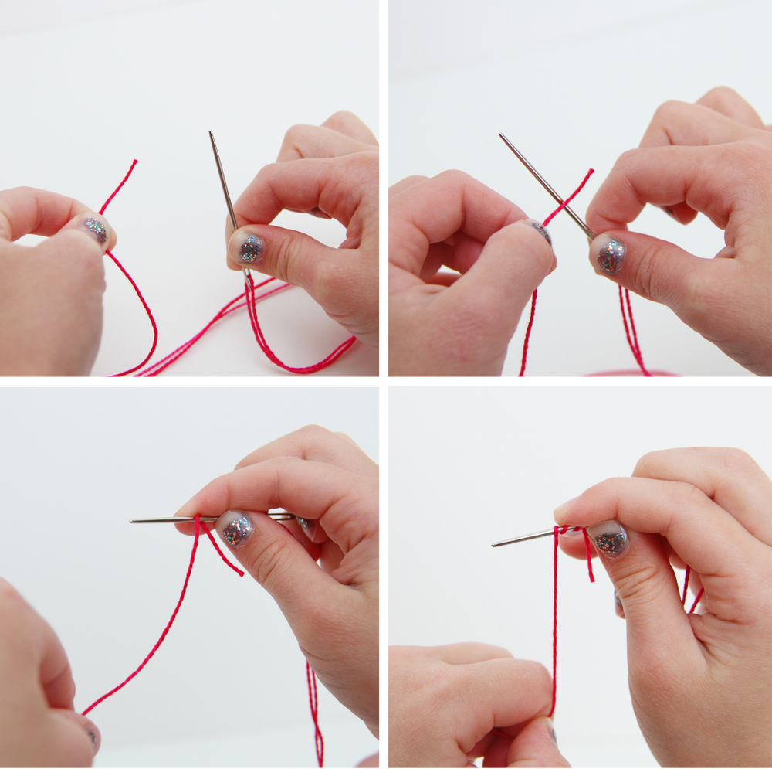
- Pull the thread in your left hand (and the 2 wraps) down the needle, toward your pointer finger.
- Pinch the 2 wraps between your pointer and thumb of your right hand and then grab the tip of the needle with your left hand.
- Keep pinching the 2 wraps and begin sliding them down the needle, past the eye hole. (If you can’t get it past the eye of the needle, you probably wrapped the thread around a bit too tight. Try again.)
- Continue pinching and pulling the little wraps between your thumb and pointer, on down the thread.
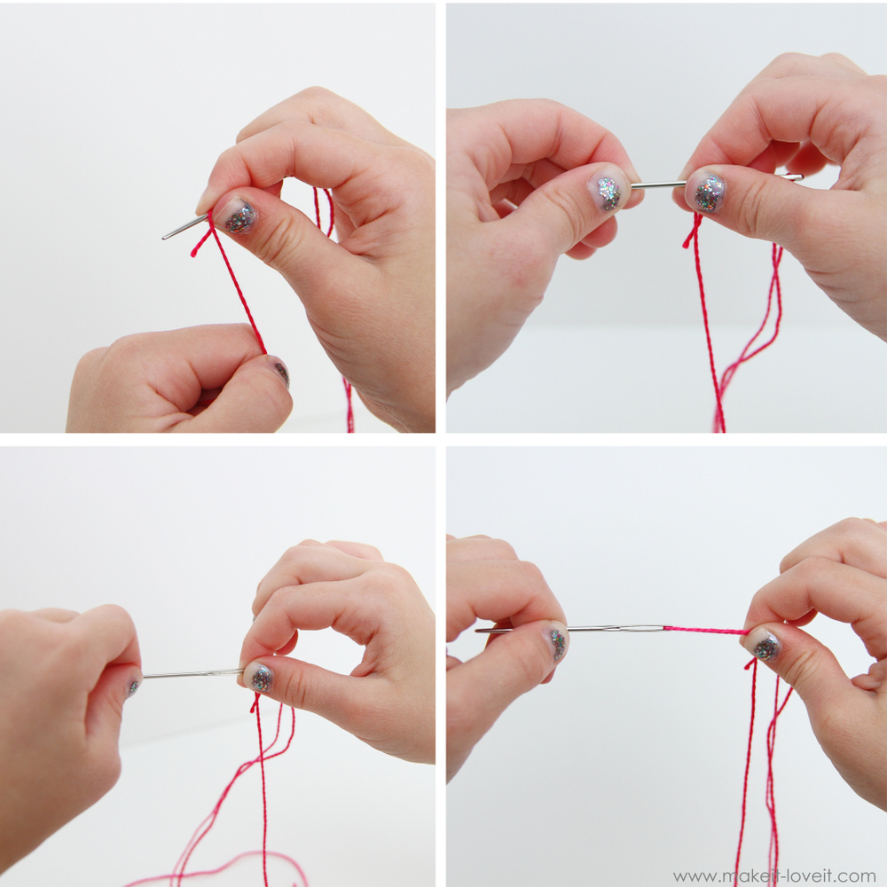

With the needle in your left hand, pinch around the eye of the needle, to keep the thread from pulling out and keep pulling the wraps in your right hand down to the end of the thread.
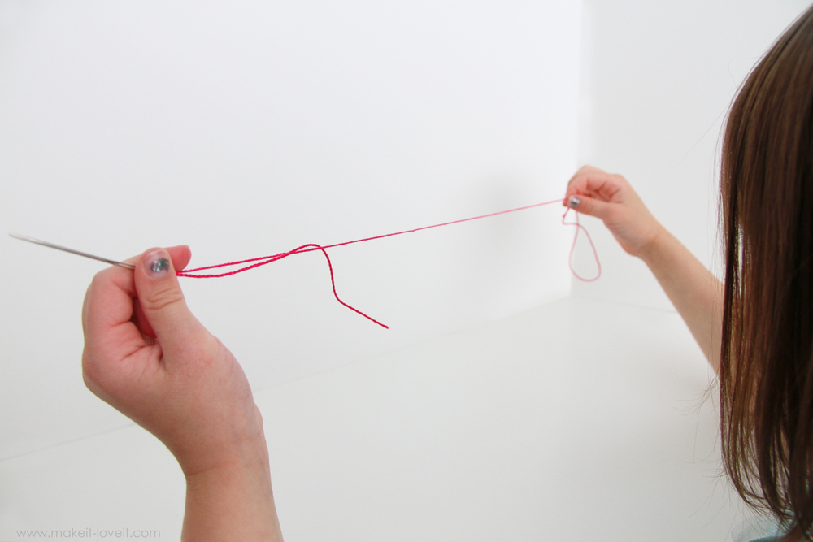

Pull until the thread stops……

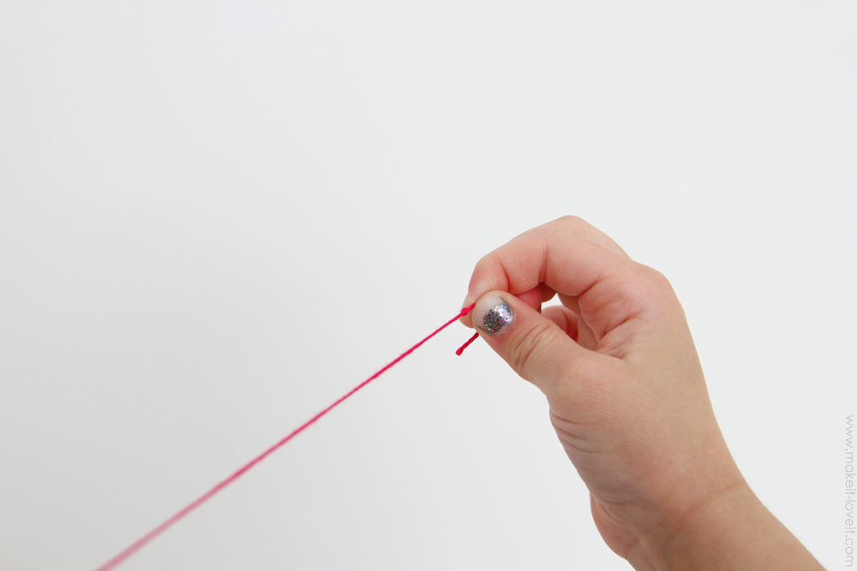

…..and you have a nice little knot at the end of your thread.

