Snipping Tool Steps

- Open; http://www.paymentevolution.com
- Scroll down to Payment Calculator + click it.
- Enter information, then click Calculate.
- Then. Click the Start/Windows button. Type in the search box “Snipping Tool” (it will look like a pair of scissors with a red ring behind them)
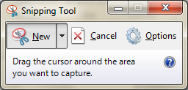
- This box will pop-up on your screen. (The rest of the screen will turn faintly white.) Click and drag a box around the results from the payment calculator.
- Click File, go down to Save As…
- Rename the picture and save it into you student drive (If you don’t, it will be lost)
It is now an actual image, and can be put into a word document.

