Look at the following pictures and decide what you think is safe and why.
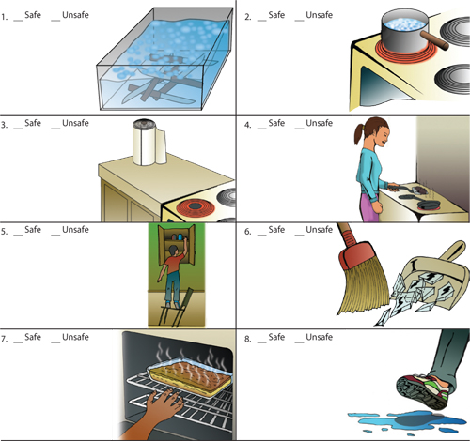
Circle all the parts that you think are unsafe in this kitchen
