Name: ______________ Block:_______

Your hip measurement = _________ + 2 to 3 inches = _______

Pattern sizes – circle the one you are making
Smaller than 35 inches | 35 inches | 37 inches | 39 inches | 41 inches | 44 inches | 48 inches

Layout of the fabric

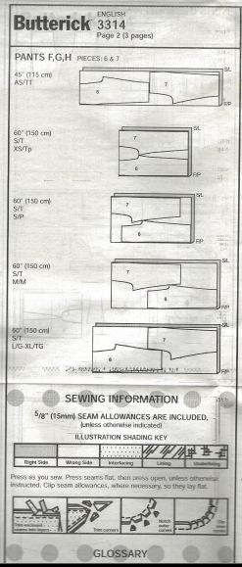 | - Fold fabric right sides together in a lengthwise fold  - Make sure selvages are even and the material lays flat  - IF MAKING PANTS: Fold your material in half – LENGTH WISE & mark with pins or tailors chalk  - Lay one pattern piece close to the top of your fabric, grain line ( ) parallel to the selvage  - Measure the grain line to the fold at each end of the arrow. Must be the same distance & pin  - TEACHER CHECK  - Now pin the rest of your pattern piece  If making PANTS - The teacher will mark and draw out your leg length  - Cut the notches outward  - Each pattern piece will have 3 notches  - Mark the two large dots and the two small dots with tailors chalk

Inner leg seam and Crotch seam Side Seams
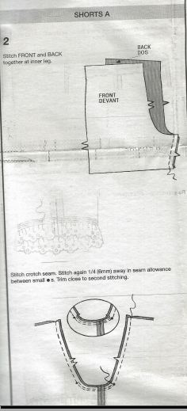 | STOP! The way your shorts/pants are right now are not your side seams  - Pin front leg to back leg good sides together  - TEACHER CHECK  - Sew at a 1.5 cm seam, straight stitch (5,A,2.5) BACK STITCH AT EACH END  - Seam finish seam allowance together using a wide multi zigzag (5,D,1.5) as close to the outside edge as possible  TEACHER CHECK  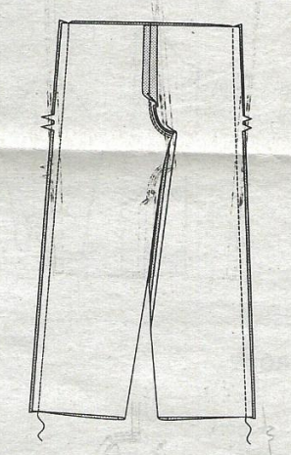

Casing/Waistband
- Fold the top of the pants to the WRONG SIDE, 1 cm, press and pin  - Pin so the Inner & outer leg seam goes toward back, crotch seam open  - Stitch (5, A, 2.5) with the edge of the pressure foot as a guide in the middle of the fold. Backstitch at the beginning and end  - Now fold the top (casing) again to the WRONG SIDE only 4 cm (make sure your elastic will fit)  - Press & Pin  - TEACHER CHECK - if not doing button hole go to step  IF you are doing a button hole for your drawstring do it now – See Teacher for instructions  - Stitch from the wrong side – use the left side of the pressure foot and line it up with the inner most fold line. Straight stitch using a (0, A, 2.5) as close to the edge of the casing. BACK STITCH AT EACH END  - Now Measure your elastic around your waist to where it feels comfortable and mark  - Insert elastic through the opening and pull through  (Use Large safety pin for help)  - Fold ends of elastic over each other and Zigzag or straight stitch closed (go forward and back 4 times)  - TEACHER CHECK | 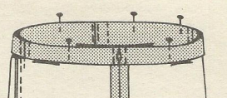  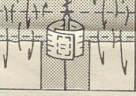

Hem for Shorts or Pants
- Fold over the end of your leg 1.5 cm and press  - Stitch (5, A, 2.5) with the edge of the pressure foot as a guide in the middle of the fold (like you did for the casing/waistband  - TEACHER CHECK  - Now fold over the edge again 1.5cm  - Stitch from the wrong side – use the left side of the pressure foot and line it up with the inner most fold line. Straight stitch using a (0, A, 2.5) as close to the edge of the casing. BACK STITCH AT EACH END.  - YOU ARE NOW DONE – TRIM ALL THREADS! AND HAND IN WITH YOUR SELF ASSESSMENT | 