- Fold fabric right sides together: lengthwise fold  - Make sure selvages are even and the material lays flat  - IF MAKING PANTS: Fold your material in half – LENGTH WISE & mark with pins or tailors chalk  - Put pattern piece as close to end of material  - Measure grain line to the selvage. Must be the same distance & pin  - TEACHER CHECK  - Now pin the rest of your pattern piece  If making PANTS - The teacher will mark and draw out your leg length  - Cut on the outside edge of the pattern  - Cut the notches outward  - Each pattern piece will have 3 notches  - Mark ALL dots with tailors chalk (3 dots on BACK, 1 dot on FRONT)  - Take the pattern piece off your fabric, put it back in the box  - Now take the other pattern and repeat steps | 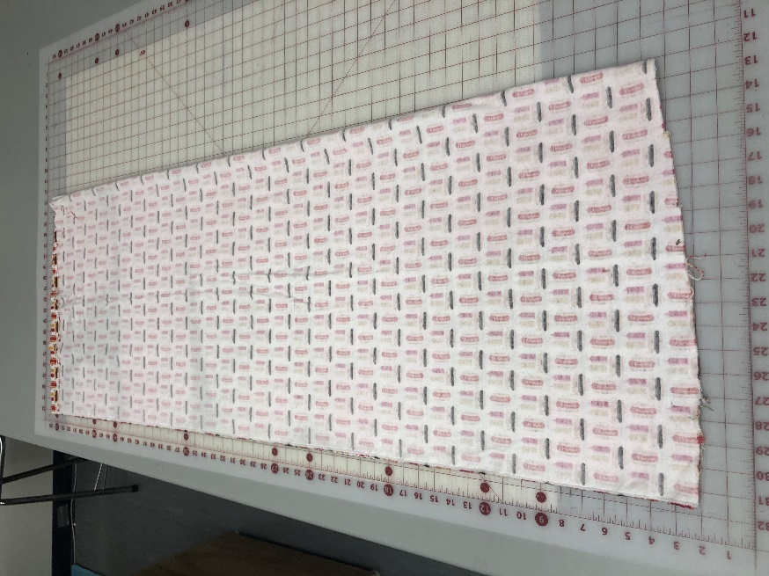  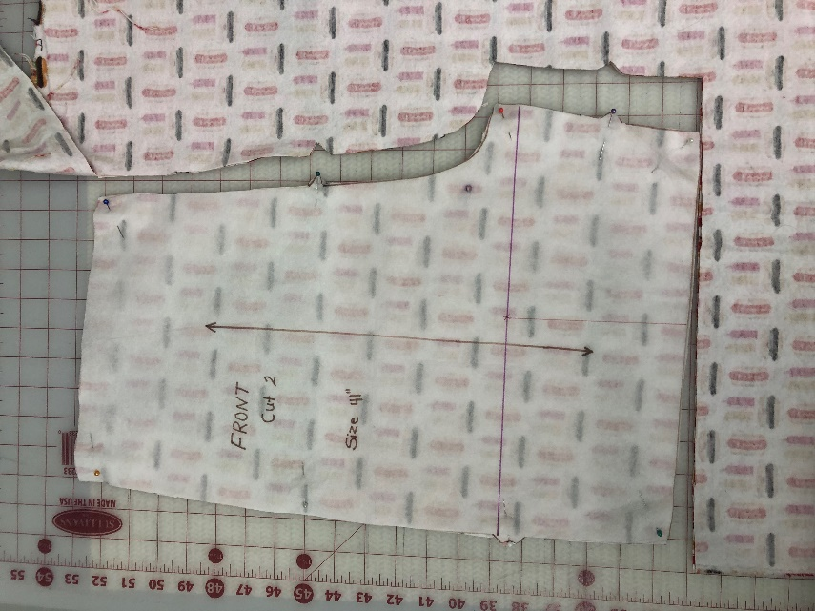  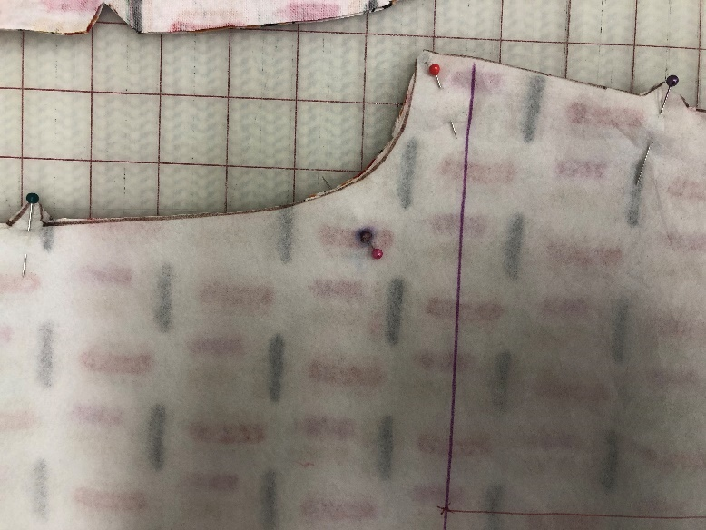(FRONT)  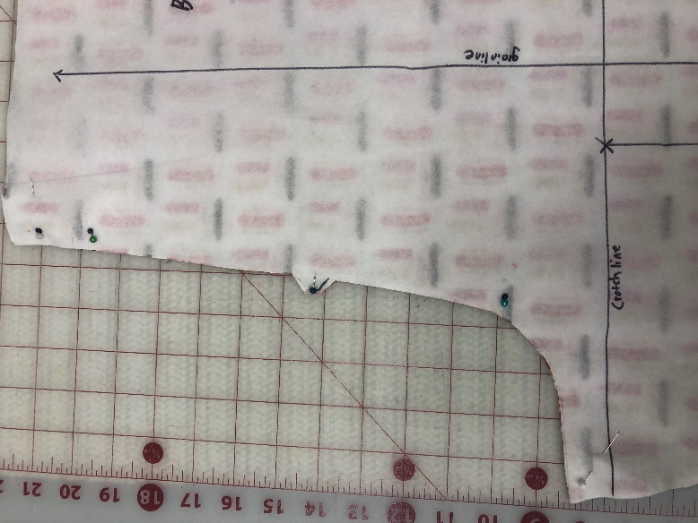 (BACK)

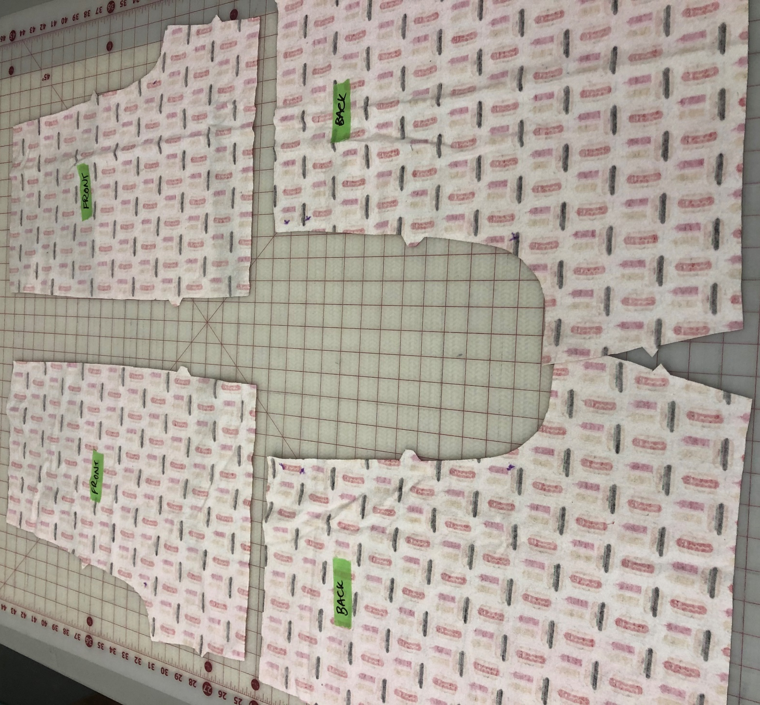
(After cutting, you will have 4 cut pieces of fabric – 2 BACK, 2 FRONT)

Inner Leg Seam  - Take 1 BACK piece and 1 FRONT piece and place right sides  - Line up the inner leg seam ONLY(back with front) and pin – Make sure all cut edges are lined up  - TEACHER CHECK  - Sew inner leg at 1.5 cm seam allowance with a straight stitch (5,A,2.5) BACK STITCH AT EACH END  - Repeat other leg  - Seam finish seam allowances together with a multi zigzag (5 D 1.5) as close to the cut edge as possible  - Repeat on the other leg | 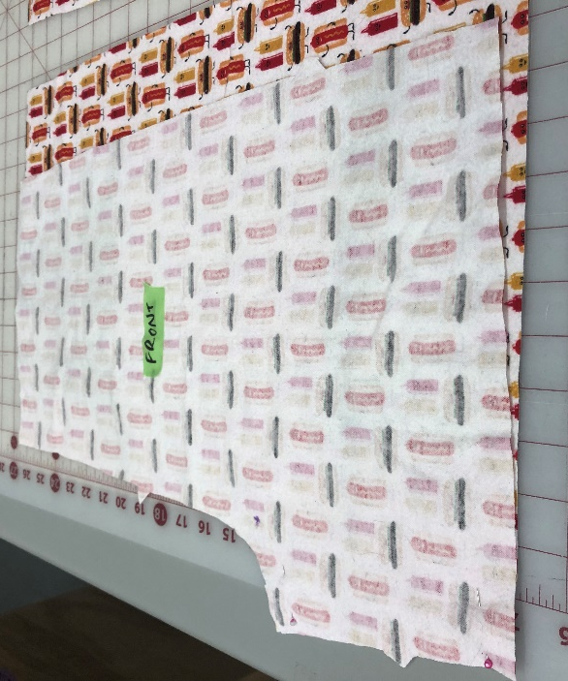  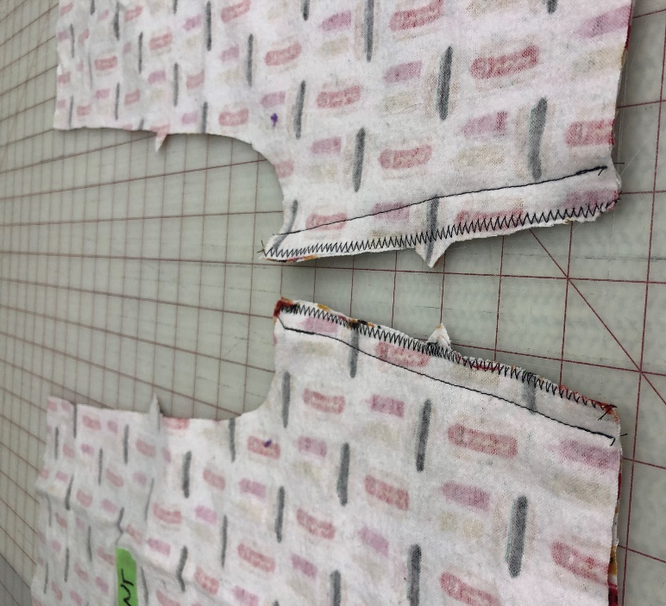  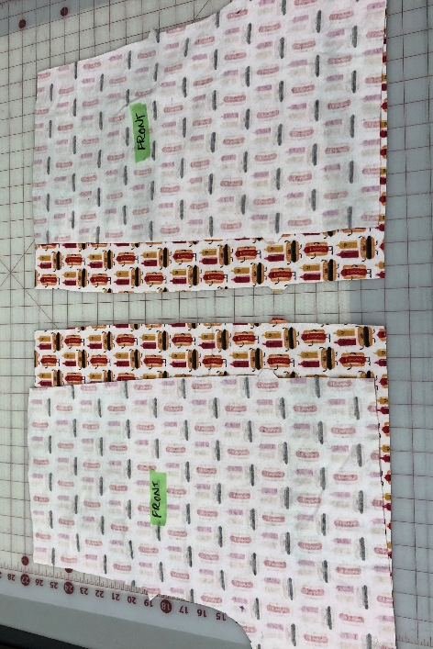

CROTCH SEAM  - Press seam toward the back of the pants  - Place stitched legs RIGHT SIDES together lining up the inner leg seam, top of front and back of pants  - Pin the crotch area, make sure cut edges stay lined up  - TEACHER CHECK  - Sew at a 1.5 cm seam straight stitch (5,A,2.5) BACK STITCH at each end. Leave the space between the two dots by the top of the pants open  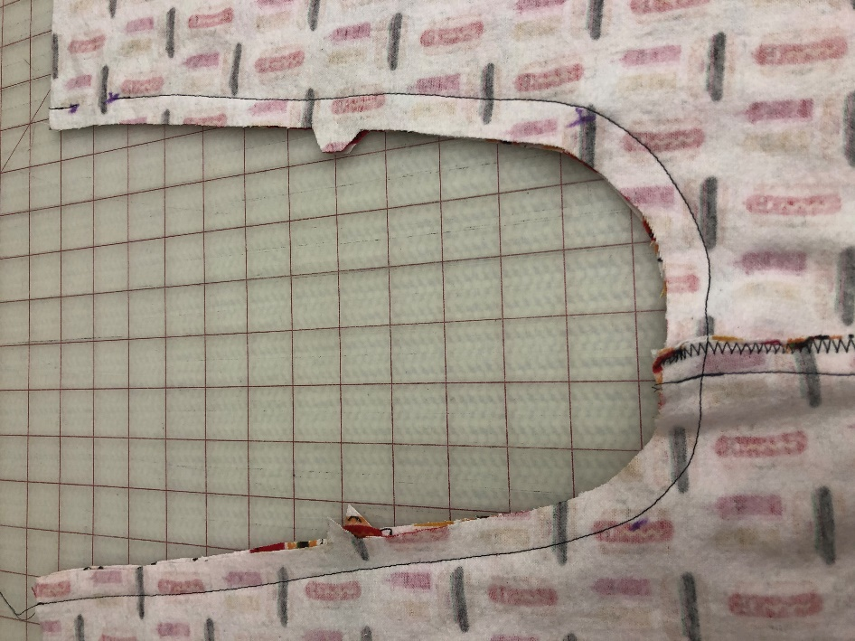  (When done sewing the first stage of the crotch seam, it will look like this)  - Reinforce the crotch seam from dot to dot in the curve just to the inside of the first stitching line  - Trim the seam allowance in the curve  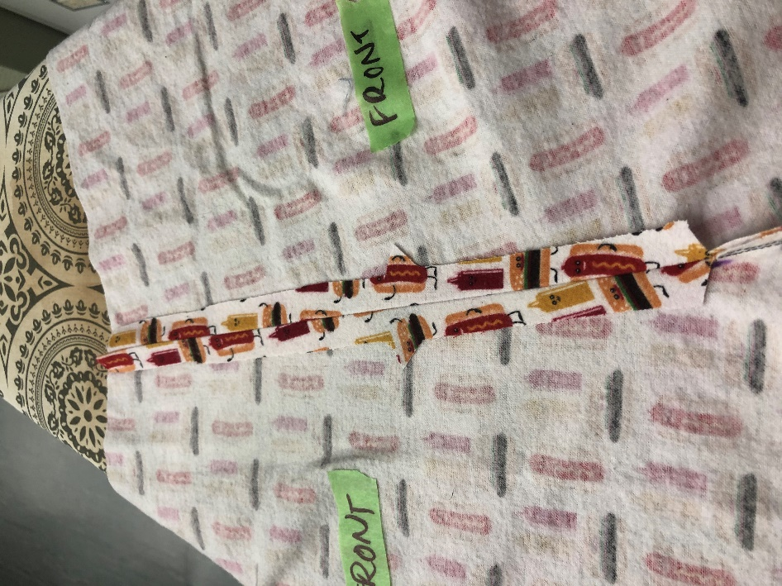  - Press other seam allowance open  - Seam finish each seam allowance separate using a wide multi zigzag (5,D,1.5) as close to the cut edge as possible  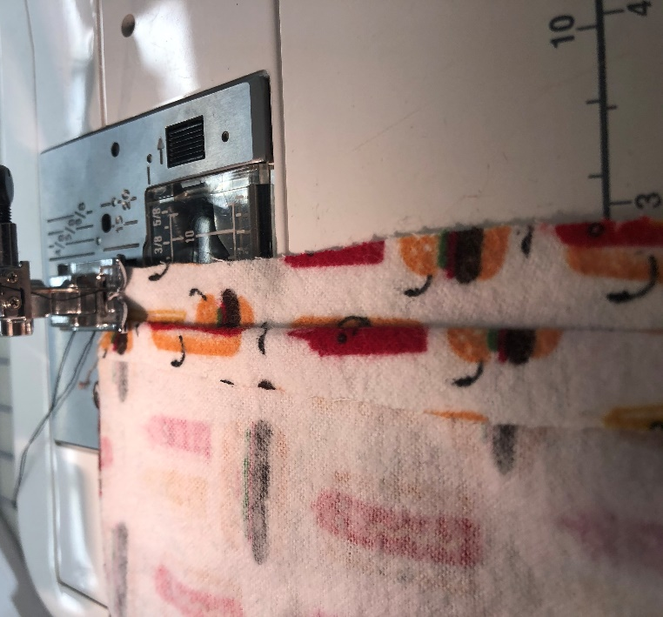  - TEACHER CHECK | 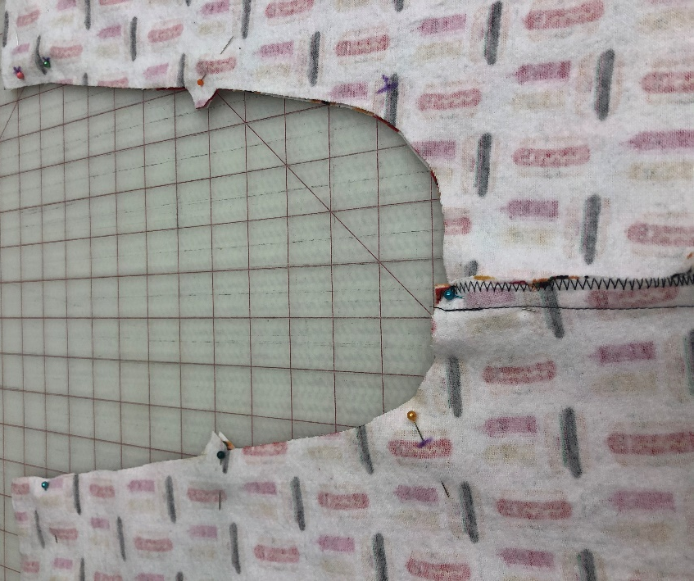  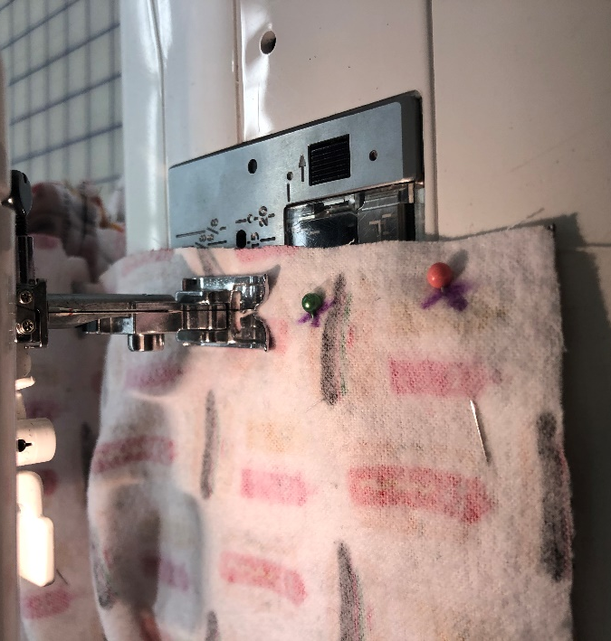  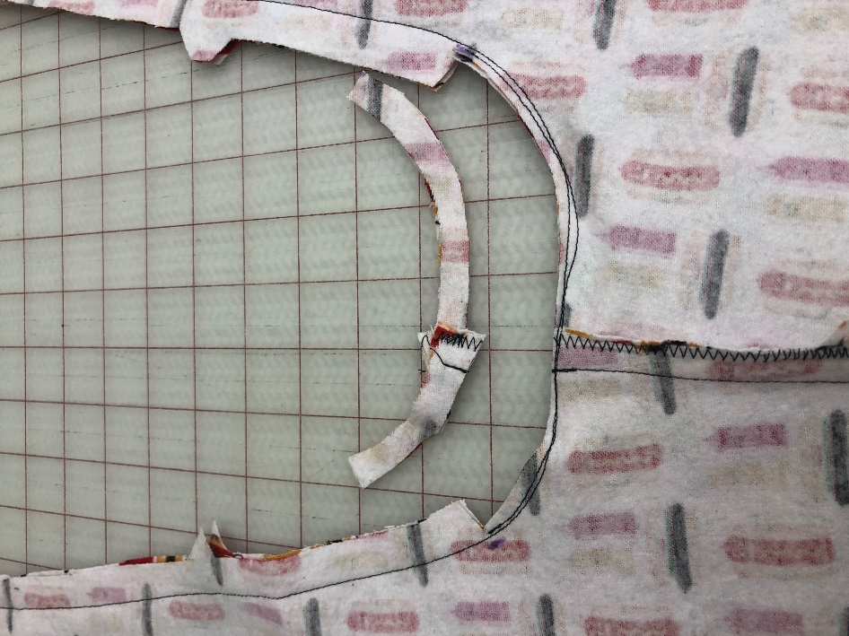  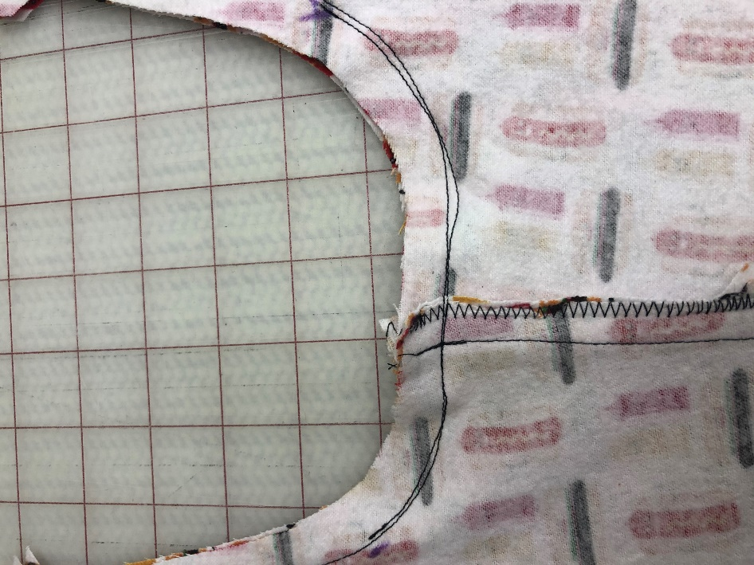

Side Seams
STOP! The way your shorts/pants are right now are not your side seams  - Place back pants with RIGHT SIDE facing you  - Bring front top of the pant to meet the other top RIGHT SIDES together (match notches)  - Pin both side seams  - TEACHER CHECK  - Sew at a 1.5 cm seam, straight stitch (5,A,2.5) BACK STITCH AT EACH END  - Seam finish seam allowance together using a wide multi zigzag (5,D,1.5) as close to the outside edge as possible  - TEACHER CHECK | 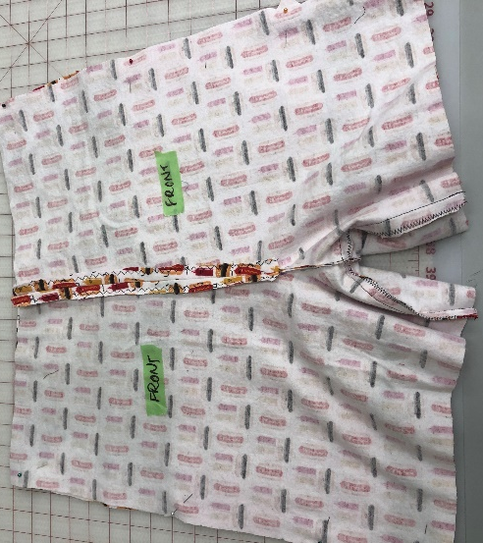  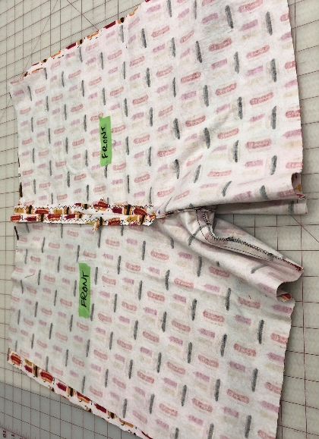  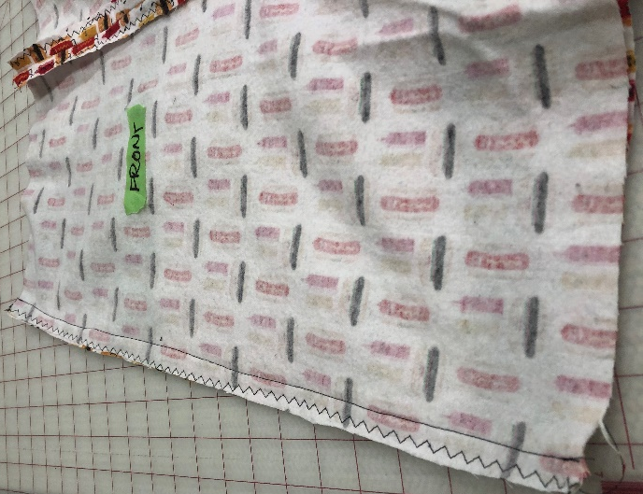

Casing/Waistband
- Fold the top of the pants to the WRONG SIDE, 1cm, press and pin  - MAKE SURE YOUR SEAMS ARE FACING THE CORRECT WAY  - Inner & outer leg seam toward back  - crotch seam open  - Stitch (5, A, 2.5) with the edge of the pressure foot as a guide in the middle of the fold. Backstitch at the beginning and end  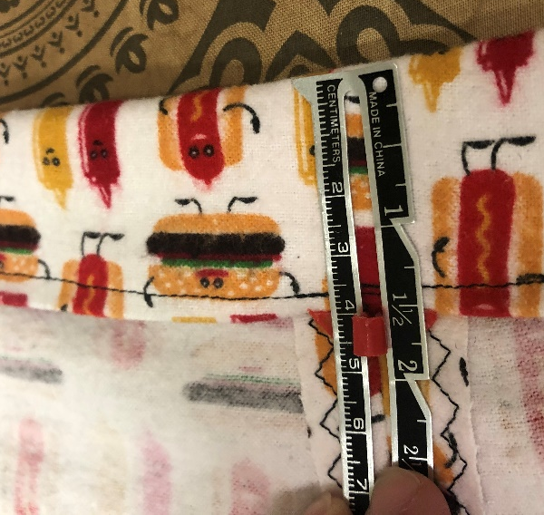  - Now fold the top (casing) again to the WRONG SIDE only 4 cm (make sure your elastic will fit)  - Press & Pin - TEACHER CHECK  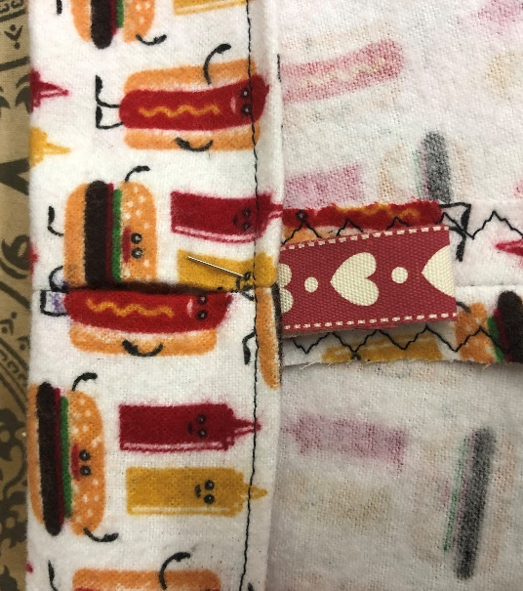  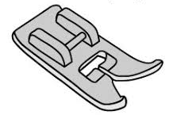  - Stitch from the wrong side – use the left side of the pressure foot and line it up with the inner most fold line.  - Straight stitch using a (0, A, 2.5) as close to the edge of the casing. BACK STITCH AT EACH END  (Sew on a ribbon tag to the back-side casing, right under the waistband opening)  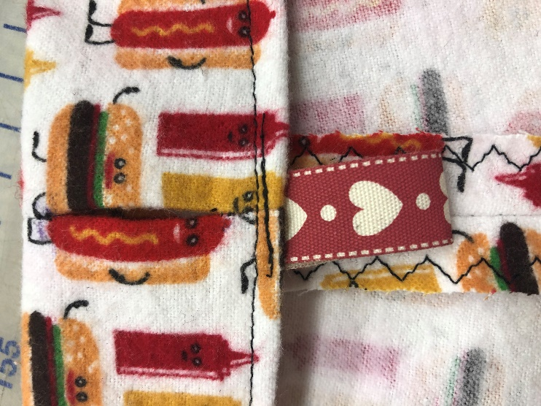  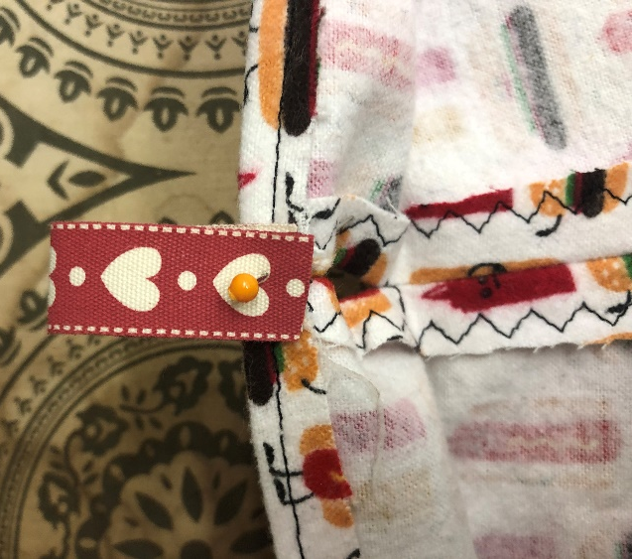 | 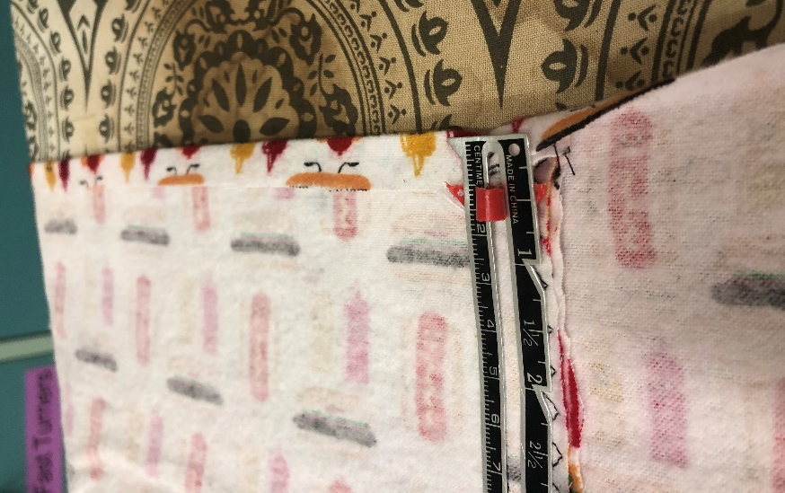  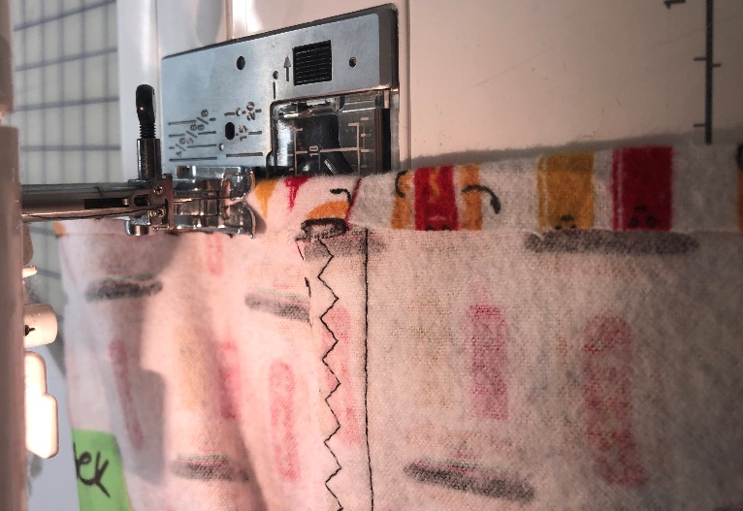

Inserting Elastic
- Now Measure your elastic around your waist to where it feels comfortable and mark  - Pin Safety pin to one end of elastic and thread thread through the opening and all the way around and out  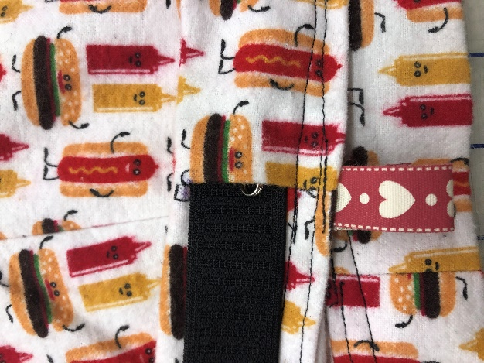  - Fold ends of elastic over each other and Zigzag or straight stitch closed (go forward and back 4 times)  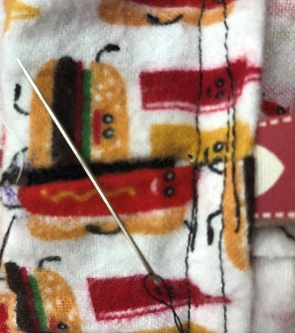  - Hand stitch the waistband opening closed using a ladder stitch. | 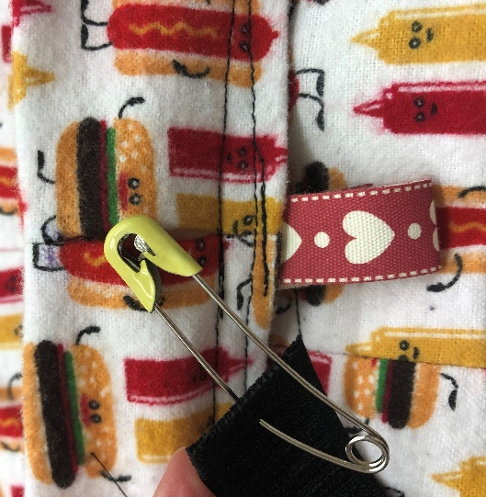  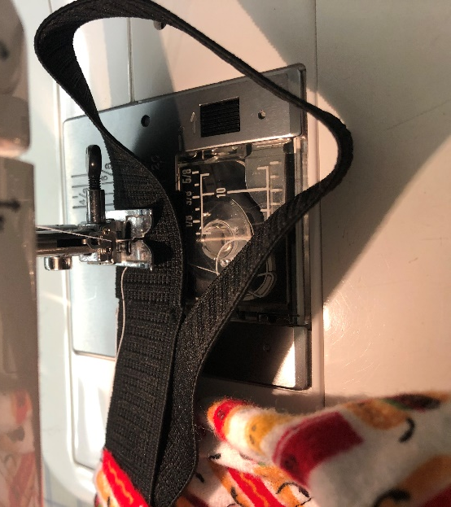  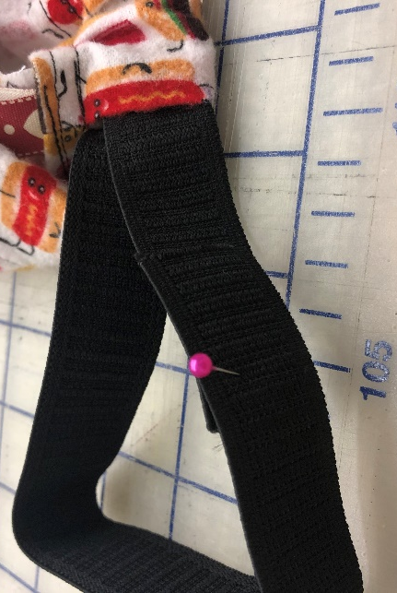
Hem for Shorts or Pants
- Fold over the end of your leg 1.5 cm and press  - Stitch (5, A, 2.5) with the edge of the pressure foot as a guide in the middle of the fold (like you did for the casing/waistband  - TEACHER CHECK  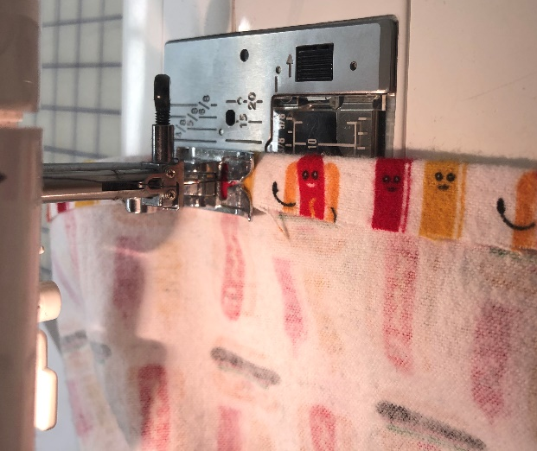  - Fold over the edge again 1.5cm  - Stitch from the wrong side – use the left side of the pressure foot and line up with the inner most fold line  - Straight stitch (0, A, 2.5) as close to the edge of the casing. BACK STITCH AT EACH END.  YOU ARE DONE – TRIM THREADS &  HAND IN WITH YOUR SELF ASSESSMENT | 