Pillow Directions
Fabric and pattern layout
- Fold fabric right sides together in the lengthwise fold
- Have your selvages lined up perfectly and that your fabric is flat (no bumps or lumps)
- Pin you pattern piece so the grain line is parallel with your selvages
Selvages
Fabric (Right sides are together -
Pillow Pattern
You cannot see them)

Cut End Cut End
Grain line
Grains line

Lengthwise fold

- Measure from your grain line to the selvages or the fold and make sure both ends to the grain line are the same distance to the selvages or fold line
- Pin corners diagonally, pin any notches, curves and then pin in between each pins so they are approximately 3 inches apart (make sure the heads of the pins are not outside the pattern pieces) Teacher Check: ___________

Cutting and Marking
- Cut the pattern on the outside of the cutting lines
- Use long even cuts, do not lift your fabric off of the table, use your non cutting hand to hold the pattern and material down
- Place a pin through the 2 marking dots and mark them with your tailors chalk on the wrong side of your material

Sewing the seam
- Pin your fabric right sides together with all cut edges perfectly even
- Start at the dot closet to you (DO NOT SEW INBETWEEN THE 2 DOTS)
- Sew a 1.5 cm seam allowance – backstitch 3-5 times
- Sew around the entire pillow ending at the other dot and backstitch 3-5 times

Backstitch 3-5 times
at each dot

REMINDERS
  - use your corner guide to help you at each corner
  - Make sure your needle is in the down position before you pivot at your corner
- Now reinforce your corners by lowering your needle into the seam about 3 cm from the corner
- Sew around the corner until the same distance on the other side

Sew just on the inside other first sewn line
Do this to all 4 corners

Trimming the corners
- Trim the excess fabric from the corners, cut on a diagonal across each corner
- CHECK WITH TEACHER BFORE YOU CUT
Place a pin between
the stitch line and the cut corner to ensure
You do not cut your stitch line!
- Do this to all 4 corners

Stuffing your pillow
- Turn your pillow right sides facing out
- Press the opening of your pillow keeping the fold even with the seams
- Push all 4 corner out using a chop stick so they look like crisp corners not
- Pull chucks of fiber fill out and stuff each corner first
- Now stuff the rest of your pillow to how thick or thin you want it
- Pin the open closed – Keep your folds even

Closing your pillow – Blind hand stitch
- Thread a hand sewing needle with matching color thread to your pillow
- Double your thread and knot at the end of both threads
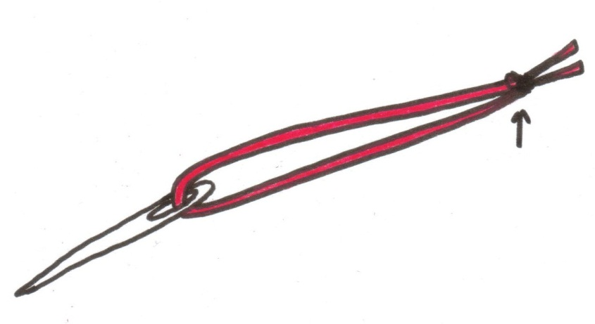
Knot

- Bury the knot down inside the fold between the layers close to one end of the opening
- Use the ladder stitch to close the hole

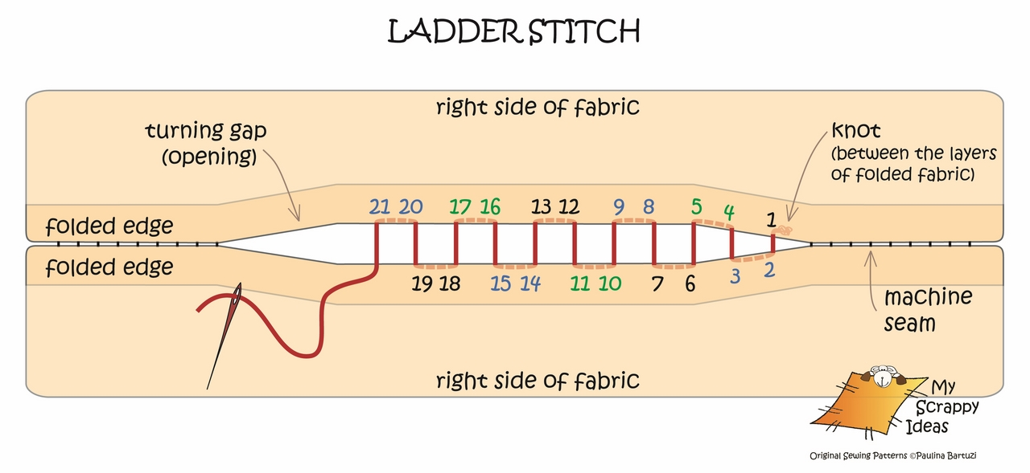

See the step by step tutorial on my website: epting.weebly.com – Textiles 8 – course info and assignments – ladder stitch tutorial.

- Make sure I cannot see any of your stitched or the ends of your thread!!
- You are now done
- Attach the Marking Criteria to your pillow and hand it in

Name: __________________________ Block:_______

Marking Criteria for your Pillow
Criteria | Expert  4 | Intermediate  3 | Beginner  2 | Starting out  1
Fabric | Right sides together |  |  | Wrong sides together
Lay out | Selvages are evenly lined up, fabric is flat, | Selvages lined up by material not flat OR selvages not lined up but material is flat | Selvages not lined up and material is not flat | Folded the wrong way – crosswise fold not length wise fold
Pattern Piece | Grain line is parallel to the selvage  Grain line is even at both ends of the arrow to either the folded line or the selvage | Grain line is parallel to the selvage  Grain line is off by less than ¼ of an inch | Grain line is parallel to the selvage  Grain line is off by more than a ½ an inch | Grain line is not parallel to the selvage of the fabric
Cutting and marking | All sides of the fabric are cut accurately. Both sides of fabric are marked with both dots | Sides somewhat cut accurately & both sides of fabric are marked with both dots OR Fabric cut accurately but not both sides of fabric are marked | Not cut accurately, both sides of fabric are marked OR Sides somewhat cut accurately but fabric is not marked with dots | Side not cut accurately and dots not marked
Sewing the seams | Right sides together, all seams at 1.5 cm and straight.  Backstitched 3-5 times at both ends  Left the gap between the dots open | Right sides together, most seams at 1.5 cm and somewhat straight.  Backstitched 3-5 times at both ends  Left the gap between the dots open | Right sides together, few seams at 1.5 cm and not straight.  Not properly backstitched at both ends  Forgot gap between the dots or too small a gap | Wrong sides were sewn together
Corners | Corners are pivoted and all corners are at 1.5 seam allowance | Corners are pivoted NOT all corners are at 1.5 seam allowance | Corners were not pivoted properly and not all corners are at 1.5 cm seam allowance | Corners were not pivoted properly and all corners are NOT at 1.5 cm seam allowance
Corners reinforces | All corners reinforced just to the outside of the original stitch line | 3 corners reinforced just to the outside of the original stitch line | Reinforced but too far from the original stitch line | Reinforced but on the inside of the original stitch line
Trimming Corners | All corners trimmed to 2 mm from corners | Almost all corners trimmed to 2 mm from corners | Trimmed too far away from stitch line or trimmed too close to the stitch line | Cut through the original stitch line
Stuffed pillow | All 4 corners well stuffed | 3 corners well stuffed | 1 or 2 corners stuffed | No corners stuffed
Ladder stitch  The beginning and end | Both knots are tucked inside, seam ends even and stitched are close to the fold lines | 1 of the following  Knot is visible  Seam ends not even  Stitches not close to fold line | 2 of the following:  Knot is visible  Seam ends not even  Stitches not close to fold line | Knot is visible, seam ends not even, stitches not close to fold line
Ladder stitch and gaps | Stitches are going through the fold lines and are not visible, not gaps or tucks of the fabric | Not all stitches going through the fold line, no gaps or tucks of the fabric | Stitches are not through the fold line, there are no gaps or tucks in the fabric | Stitches are not through the fold line, there are gaps and/or tucks in the fabric
Hand sewing | Invisible – very hard to tell where they stitched pillow closed | Can see a little bit | Can more than 50% | Can see the entire stitching

