Dear Parents/Guardians,

I am asking for the permission of your son/daughter’s picture to be taken while they are creating their sewing projects during class as well as their final results. The pictures will be used to showcase what the Grade 8 to 12 textiles students have designed and created in their classes. I find it important to showcase and celebrate what the students have accomplished to their peers, teachers and parents.

The pictures of the students working and their completed projects will be displayed on Mrs.Epting’s “public” website (epting.weebly.com), showcased in print form in the classroom and on the bulletin board outside the classroom, as well as in a power-point presentation for the Grade 7 walk through. With your permission I would like to post pictures of the finished projects with the student’s grade (8 to 12) and first name only.

Please complete this form, including your son/daughter’s name, and check the appropriate box. Have your son/daughter return this sheet to Mrs. Epting as soon as possible.

Student Name:_______________________________ Grade: _____ Block:____
Please print clearly

I allow my son’s/daughter’s picture to be taken and displayed (in school or on the “public” website) in print or powerpoint form with only their first name and grade.

I do not allow my son’s/daughter’s picture to be taken and displayed (in school or on the “public” website) in print or powerpoint form with only their first name and grade.

Parent/Guardian Name:___________________________________________
^{PLEASE PRINT}

Parent/Guardian Signature:_________________________________________

Thank you very much for taking the time to fill out this sheet. If you have any questions or concerns please contact me at 604 882-0220 ext.262 or email me at tepting@sd35.bc.ca.

Sincerely,
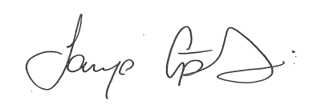
Ms. Epting
WGSS – Textiles Teacher

