Instructions on how to get students to create an account
- Go to www.myblueprint.ca
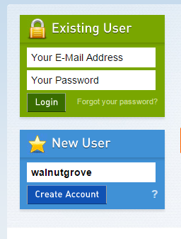
- Create New User and enter Activation Code: walnutgrove
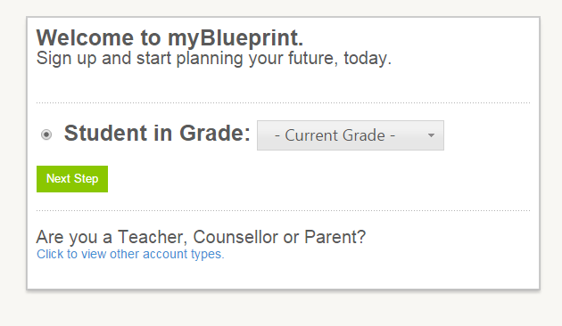
- Select Grade
- Enter Personal Information
USE FULL FIRST NAME AND LAST NAME AND ACCESSIBLE EMAIL
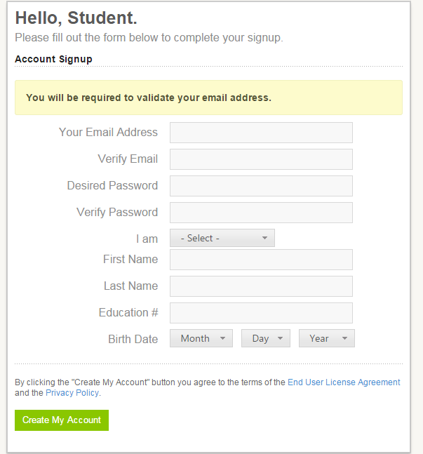
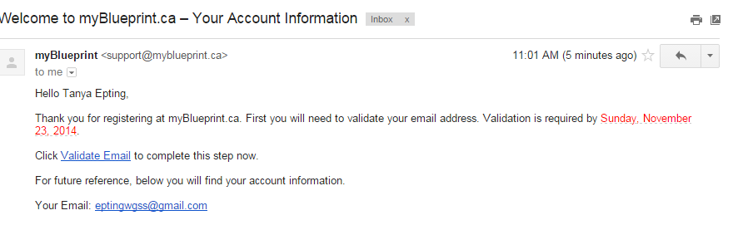
- Have students sign into their email and validate their email address.
- Go back to myblueprint and click on settings icon (top right of your screen)

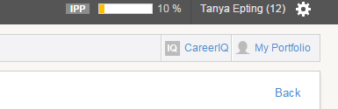
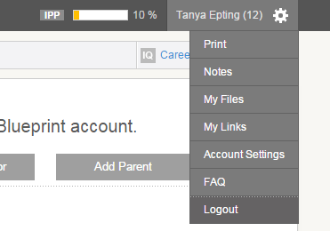
- Click on “my links”

- Select your grad trans teacher and click send request

