How to get started on My Blue Print
- If you do not know what type of career you would like to study for Post-Secondary Education a great way to get more information is to do the assessments.

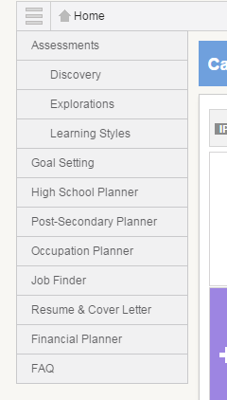
Go to the drop down menu and then select
Explorations

You should also do the learning styles assessme assessment once you finished

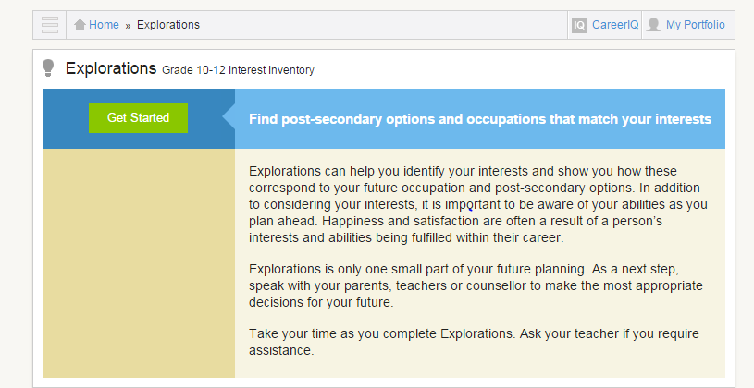

Go through the entire question in the Explorations. You will end up with a few major categories/fields in which you can go through and see what each of those jobs do and what is required.
- You can select the level of education as well
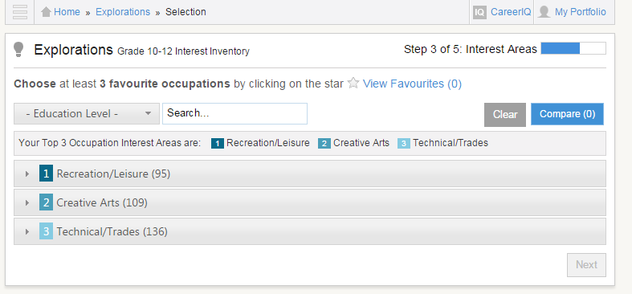

- Now you can choose your favorites and compare what they are
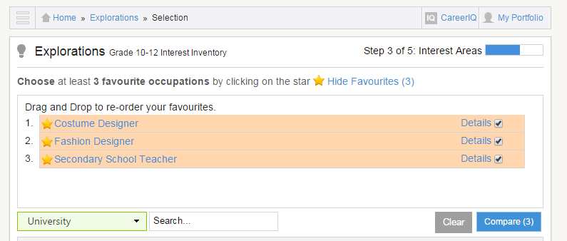

- Here is the comparison chart of the 3 careers that were selected as favorites
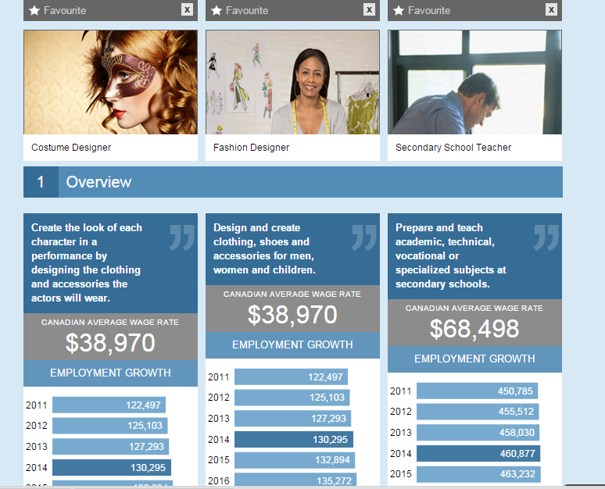
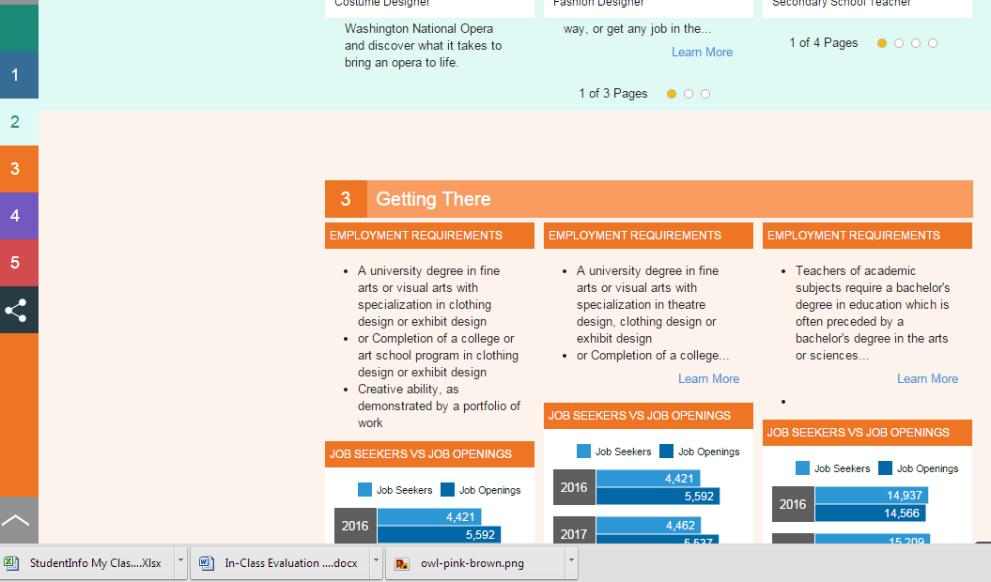
Go to the side menu bar
and it gives information on
what the job is like, how can
you get there, what types
job growth is projected as
well as job postings that are
real time (they are constantly
being updated)

- Once you have chosen your field or you know what university, College or Apprentice program you would like to do you can now compare them.
- Select the province
- Select which Post-Secondary Education you want (if gives you the amount of institution that are in your fields of choice
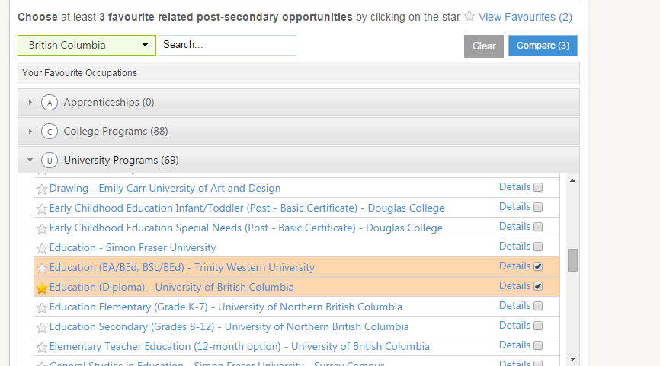
- Select your favorite ones and you can compare them again to see what the education costs, what the program is all about etc.
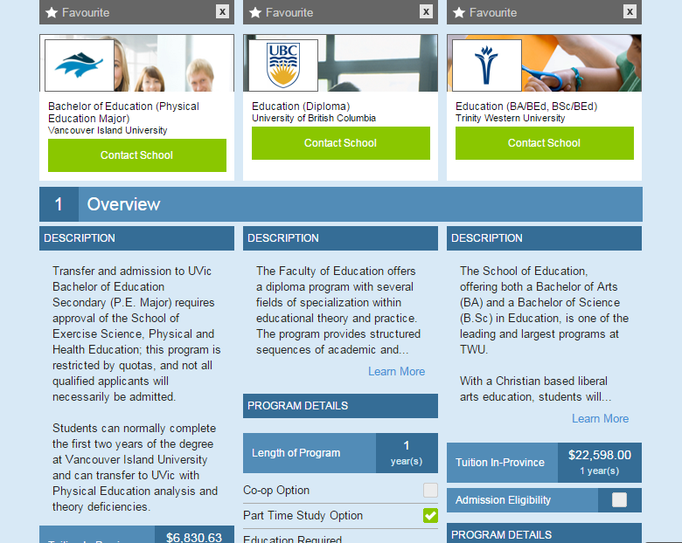
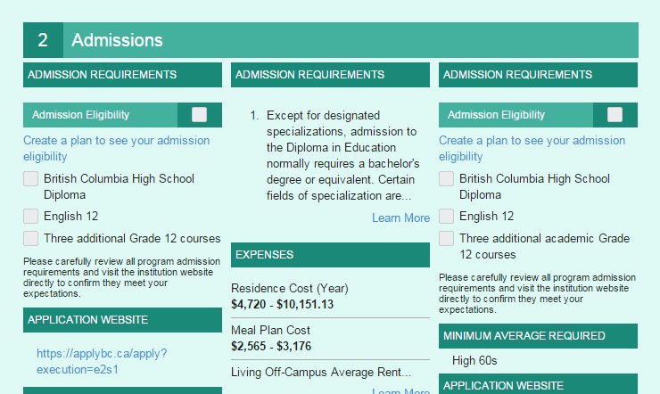
This tells you what Highschool courses you should have to apply.
Once you scroll through the comparison charts it will also tell you how much it will cost etc. All of this information can be cited into your presentation.

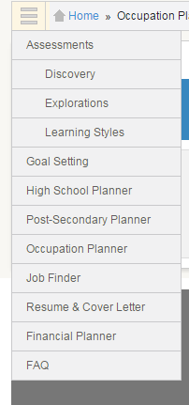
You can also select from the drop down menu
- Post Secondary School Planner
- Occupation Planner
- Job Finder
One may just use these if you already know the field in which you would like to study
- When you have finished with your Career and post secondary Schooling it is time to do a budget. Go to Financial Planner in the drop down menu and start your budget

- Put a Budget Name and then select Create Budget
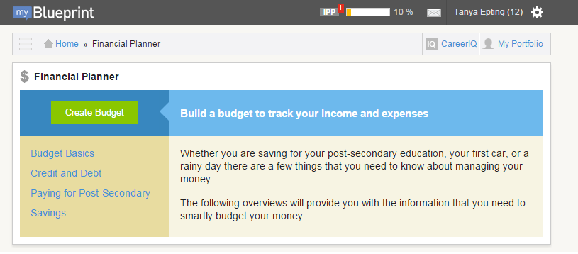
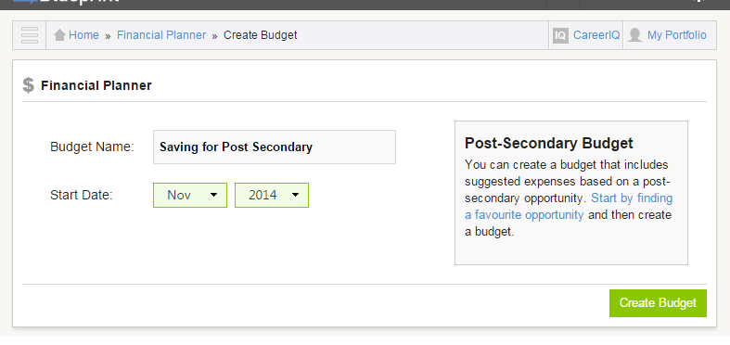
- Now you have finished with My Blue Print. All of this information is saved and you are able to access this at any time
- Play around on the site and investigate anything else you are interested in

