Name: ______________ Block: _____________

Measuring Your Body Step-by-Step
You might want to print out this page so that you can write down your measurements after each step:

Shoulder to shoulder
Measure in a straight line from the outer edge from one shoulder to the other.
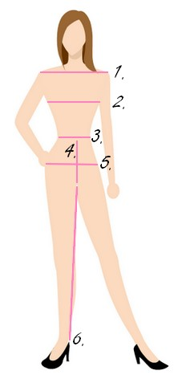

Bust
Under your arms, around the fullest part of your chest (usually on your nipple area). Wrap the tape around your back and forward to the fullest part of your bust.

Natural waist
Around the narrowest part of your torso.
This is one of the areas we tend to pull in when it is exposed. That's natural. I do it myself when I'm wearing my bikini or a fitted dress. But we need to find the exact waist measurement, so avoid holding your breath.

Hips
Measure around the widest part of your hips (usually the area where your hip bones are located). This should be done with your feet close together.

Rise
Measure from your natural waist down to your crotch. Hold the tape a little loose, gently pull it through the legs (from your crotch, between your legs) and up to the same level as your natural waist.

Inseam
From crotch to the inside of your ankle. Start from the ankle and up. This is best done with a partner. PS: This is how you find your best pants length (petite, average or tall)

