Laundry Care Symbols
Why are there international Laundry Care Symbols?
_________________________________________________________________________
The 5 basic symbols
__________ ___________ _________ ___________ __________ __________
Following these symbols as labeled ensures that your textile article will NOT stretch, shrink or change color.
Dots within a symbol pertain to _________________________
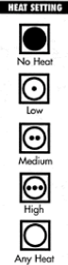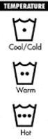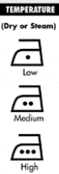
Temperature Setting
● Low
●● Medium
●●● High
Lines under the laundry symbol pertain to ____________________________________
_____________________________________
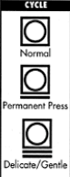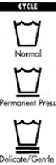
Line Setting
No line = Normal setting
= Permanent Press
= Delicate/Gentle

Iron temperatures of any blended fabric (cotton/Polyester) should be based on the fiber that is most ____________________________________________.
When in doubt, it is better to have it too ___________ than too __________________
Examples of special symbols
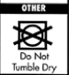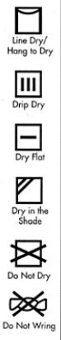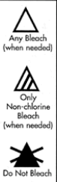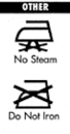
Dry clean, any solvent other than trichloroethylene
Example of Clothing labels from actual clothing – what do the symbols mean?
- 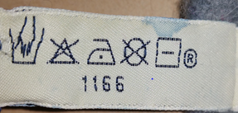
- ___________________________
- ___________________________
- ___________________________
- ___________________________
- ___________________________

- 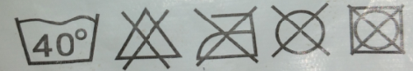
- ________________________
- ________________________
- _________________________
- _________________________
- _________________________

- ___________________________
- ___________________________
- ___________________________
- ___________________________
- ___________________________

- ___________________________
- ___________________________
- ___________________________
- ___________________________
- ___________________________
- ___________________________

- 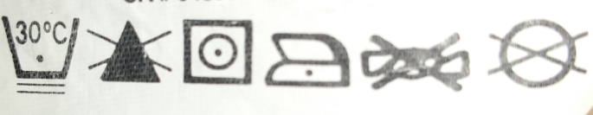

- 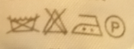
- ___________________________
- ___________________________
- ___________________________
- ___________________________
- ___________________________
- ___________________________
- ___________________________
- ___________________________
- ___________________________
6. 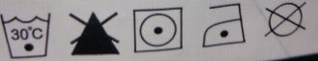

Name:______________________
Match the correct symbols with the following care message
- ____ machine wash in hot water
- ____ tumble dry delicate cycle
- ____ do not wash
- ____ hand wash
- ____ use any bleach as directed
- ____ hand to dry
- ____ tumble dry low heat
- ____ dry clean only
- ____iron low temperature
- ____ do not dry clean
- ____ do not wring
- ____ tumble dry no heat
- ____ delicate cycle, cold temp
- ____ iron high heat
- ____tumble dry any heat
- ____ do not bleach
- ____ iron no steam
- ____ do not iron
- ____ dry flat
- ____ do not tumble dry
A | B.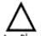 | C.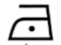 | D. | E.
F. | G. . | H. | I. 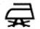 | J.
K. | L. 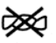 | M. | N. | O.
P. | Q.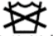 | R. | S. | T.

