How to make and bind a quilt – Advanced Method
Jacob’s Ladder Quilt
Choose 2 or 3 different fabrics. When choosing your binding it can be the same as one of the colors you already have or a contrasting color.
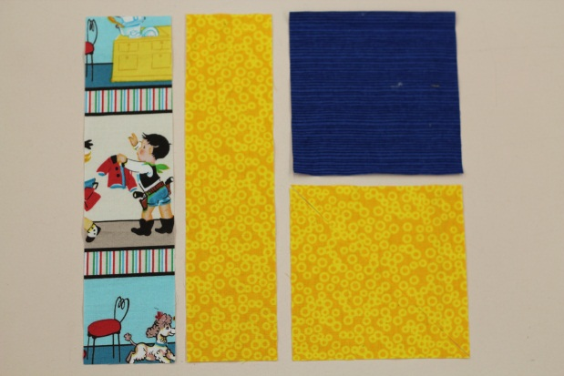 | - Cut the following pieces  - 2 pieces at 4 ^{7/8} X 4 ^{7/8} inches  - (2 different colors these will be cut on the diagonal)  - 2 strips at 2 ½ X 10 inches  - 1 Strip of Binding 2 ¼ inches wide by 40 inches long
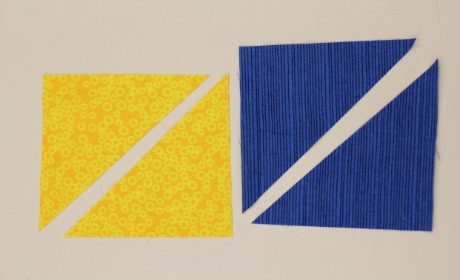 | - Cut your two square on a perfect diagonal
- Put your ¼ inch foot on your machine
- Set your stitch at 5, A, 2
- Check your tension on a scrap piece of fabric
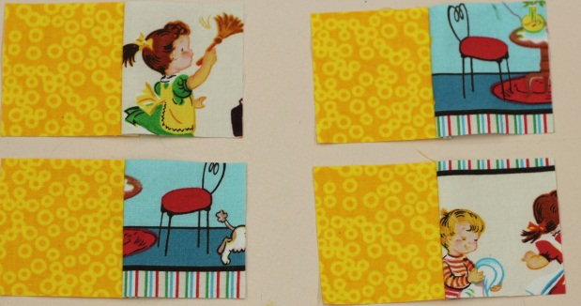 | - Take the 2 long strips and put them right sides together and stitch at a ¼ inch seam allowance  - Make sure edges are perfectly lined up  - You do not need to backstitch  - Press seams to the dark side  - Cut the long strip into 4 2 ½ X 2 ½
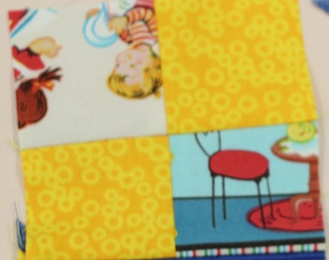 | - Match up 2 of the 2 toned squares perfectly  - Sew right sides together with a ¼ inch seam allowance to create a 4x4 square. (make sure you alternate the colors)  - You should now have 2 four X four squares
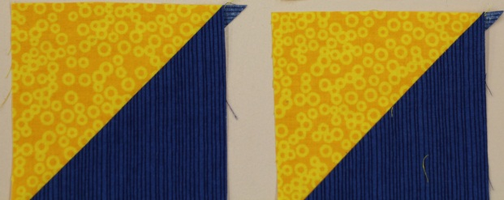 | - Sew your diagonal seams right sides together with the 2 contrasting fabrics, ¼ inch seam allowance  - DO NOT stretch the bias as you sew  - Press toward the dark color
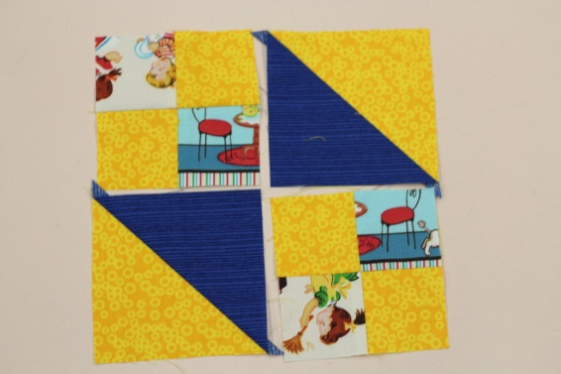 | - Now you have 4 new squares in total  - You need to decide how you are going to arrange your squares – this is entirely up to you
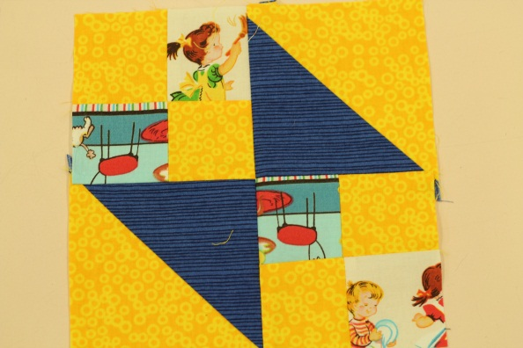 | - Sew one of the diagonal squares with a 4X4 square, right sides together with a ¼ inch seam allowance  - Sew the second diagonal square with the other 4X4  - Press seams to the darkest side  - Sew the two new rectangles right sides together to create you final 8 ½ by 8 ½ square  - BE CAREFUL to match up the middle point!
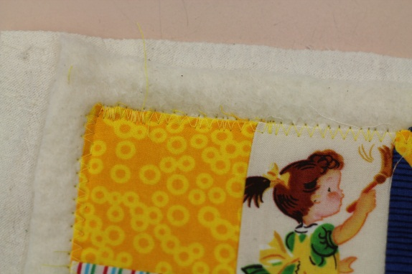 | - Cut your backing and batting 1 inch larger on all fours sides as your quilt top  - Use the spray adhesive and spray the backing with the wrong side facing up  - Place the batting onto of the backing and smooth out  - Spray the batting, place the quilt onto of the batting and smooth out  - Make sure you gently pull at where the fabrics join each other to prevent puckering when you sew
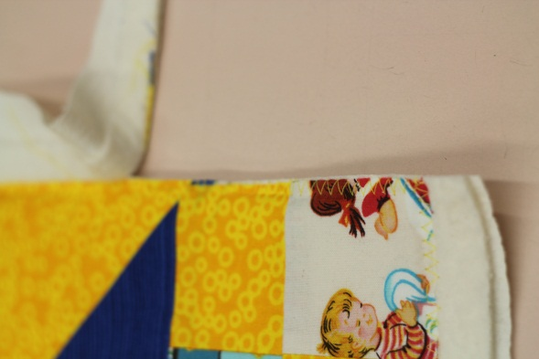 | - Set your pressure foot tension dial to 1 or 0  - Use a scrap fabric with batting and back to test it out.  - Use a medium zigzag and stitch the outside of your quilt  - Now decide what top design you are going to use and stitch the top  - Stitch in the ditch, channeling or free motion  - Once finished trim the backing and batting
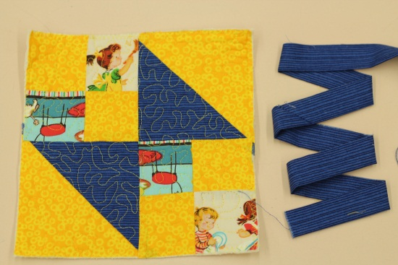 | - Fold your binding in half and press  - Sew the binding to the back side of the quilt  - (not like the picture below)  - Line up the raw edge of your binding to the raw edge of your quilt – start just off of center
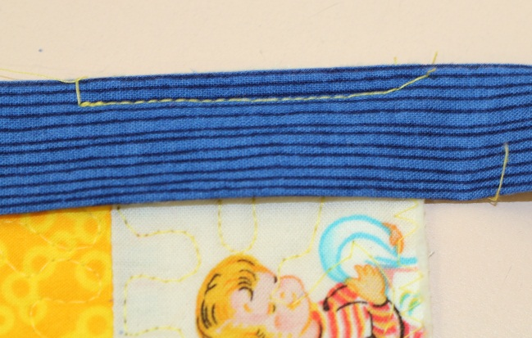  Going north then south for your binding  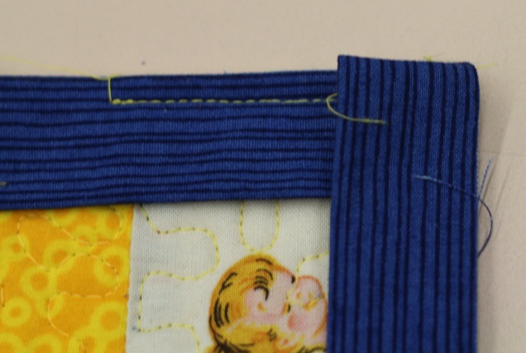 | - Sew ¼ inch seam allowance  - Stop just before the corner and sew on a diagonal off  - Bring your binding and pull it away from you and then towards you creating an overlap  - Make sure the edges of the folded over area are square to the corners  - Sew again at ¼ inch seam and continue around the other 3 corners  - Stop once you are ½ past the last corner
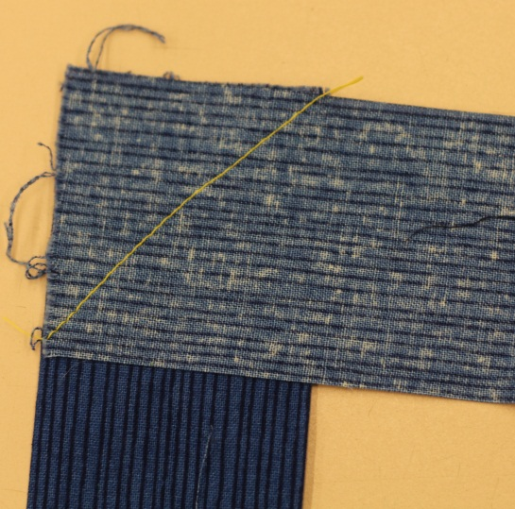  Extra fabric  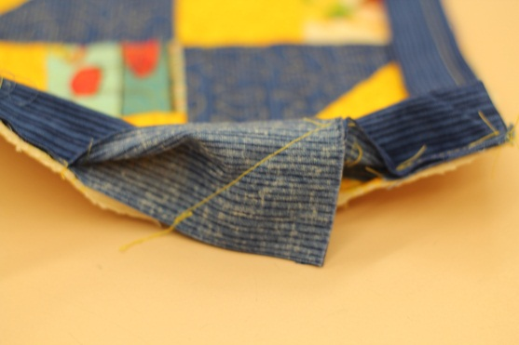 | - Overlap the two ends of the remaining binding that is not sewn by 2 ¼ inches  - Sew the two binding pieces right sides together lining them up like the picture and sew corner to corner  - Make sure the binding fits snug enough before you trim the excess fabric (Teacher check)
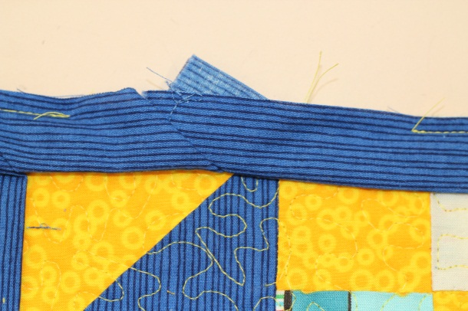 | - Finish sewing the rest of the binding to the quilt  - Press the binding to the other side of the quilt and pin  - Top stitch from the right side of the quilt as close as you can to the edge  - At the corner pull

