Name: __________________________ Block:_____________

What is a Hem?

* finished bottom edge of a garment
* May be invisible from the outside or decorative depending on fabric and what you want

Criteria

* Must hang evenly, No lumpiness and correct hem option for the fabric and style of garment

**Steps in preparing the hem**

1. Pin the hem carefully
   1. Make sure your hem is parallel to the floor and you pin every 5 to 8 cm
   2. If you have a circle skirt, or your fabric is cut on the bias or you are using knit material allow your skirt to hang up 24 hours (allowing it to stretch)
   3. Wear the shoes you would use when wearing this (especially if garment is long or pants)
2. Press up the hem the desired amount
   1. Reduce the bulk by trimming seam allowance half of the width
   2. If when pressing the hem leaves a ridge place a brown paper bag between hem and garment when you press
3. Standard Depths of hems

Straight Skirt - up to 3” or 7.5cm

A line or flare skirt or pants – 1 ½” to 2” or 3 to 5cm

Circle skirt – narrow rolled edge up to 5/8” or 1.5cm

1. Finish the hem EDGE in some way
   1. Serge the edge
   2. Finish with seam tape, binding or stretch lace
   3. Clean finish (press under the edge ½ cm and straight stitch)
   4. Zig zag or mutli zigzag (depending on weight of material)
2. Choose your type of hem you want for your skirt

3 categories: Fused Hem, Machine Stitched Hem, Hand sewn hem

**Cut 5 pieces of your extra skirt material 5” X 5” on the grainline**

1. **Fused Hem** – Great for very sheer or lightweight fabric or very heavy fabric

* Serge or multi zigzag one edge, fold and press this edge up 3 cm to the wrong side
* Open up the fold so your material is lying flat
* Measure the strip of fusing the length of you hem and place the “rough side” of the fusing tape to the wrong side of the serged/zigzagged edge
* Place a press cloth on top and press for 3-5 sec
* Now peel off the paper from the fusing tape
* Fold material at the crease line again and press in place (should be at least 10 sec

|  |  |  |  |
| --- | --- | --- | --- |
| **Criteria for Fused hem** | **Yes** | **Partially** | **More practice** |
| Hem serged/zigzaged straight |  |  |  |
| Pressed up evenly |  |  |  |
| Fusing close to top edge and holds |  |  |  |

1. **Machine Rolled Hem** – good for sheer, lightweight to medium weight or a circle style skirt
   * Press one long end to wrong side 1.5cm
   * Sew close to the fold
   * Trim excess hem close to the stitching line
   * Press up a small hem again, folding the stitching line to the wrong side
   * Sew again close to the inside folded edge

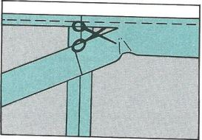 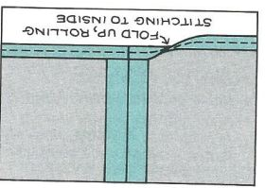 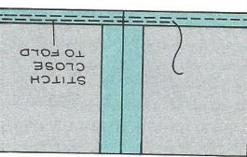

|  |  |  |  |
| --- | --- | --- | --- |
| **Criteria** | **Yes** | **Partially** | **More practice** |
| Narrow hem |  |  |  |
| Excess hem trimmed even |  |  |  |
| Hem rolled again evenly |  |  |  |
| Stitched close to inside fold |  |  |  |

1. **Top Stitching** – make a row of continuous stitches on the top or right side of a garment or other article as a decorative feature. Good for heavier fabrics or hems that are quite straight around

* Serge, clean finish, multi zigzag or bind one edge of the sample piece (which will be the Cut edge of the bottom of the garment
* Press the hem to the wrong side up 4 cm or 1 ½”
* Pin from the Right side
* Stitch as close to the “finished” edge of the hem – stitch from the Right side so it is straight
* Make sure you start and stop in an inconspicuous spot

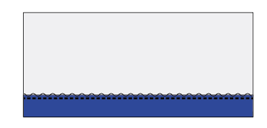

Wrong side

Top stitching close to the “finished” edge of the hem

|  |  |  |  |
| --- | --- | --- | --- |
| **Criteria for Topstitching** | **Yes** | **Partially** | **More practice** |
| Edge is finished – serge, clean finish, multi zigzag or binding |  |  |  |
| Hem pressed to 4 cm or 1 ½” |  |  |  |
| Stitching is close to the “finished” edge |  |  |  |
| Stitching is straight and backstitching is in an inconspicuous place |  |  |  |

1. **Hand stitching – Vertical Hem stitching –** best for narrow skirts without other topstitching
   * Clean finish one long end of sample (press to wrong side ½ cm and stitch in the middle)
   * Press hem to wrong side 3 cm
   * Thread a hand sewing needle with a single thread and tie a knot at the end
   * Stitch through the hem edge at the right end of your sample, this will fasten your thread
   * Now catch 1 thread of your garment fabric right above the hem edge and direct the needle diagonally to go through the hem fold approx. ½ cm to the left
   * Continue to the end and tie off your thread in your clean finish

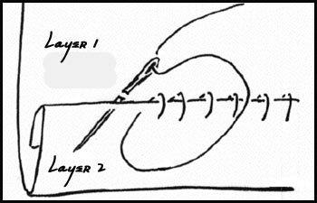

|  |  |  |  |
| --- | --- | --- | --- |
| **Criteria** | **Yes** | **Partially** | **More practice** |
| Hem finshed with a clean finish and pressed up 3cm |  |  |  |
| Only 1 thread picked up in garment fabric |  |  |  |
| Stitches even, small and ½ to 1 cm apart |  |  |  |
| Stitching is invisible for outstide |  |  |  |

1. **Hand sewing – Catch Stitch** – Used to stitch a flat edge and has more movement

* Serge one edge and press up 5cm
* Thread a hand sewing needle with a single thread and tie a knot at the end
* Work from left to right, start at the left end of your sample, hide your knot on your serged edge. Pick up one or two threads on garment directly above the hem



* Move ½ to 1cm to the right and take a small stitch in the hem only

just down from the serged edge

* Move to the right and repeat. Stitching should look like and X

|  |  |  |  |
| --- | --- | --- | --- |
| **Criteria for Catch stitch** | **Yes** | **Partially** | **More practice** |
| Hem finshed with a serge finish and pressed up 5cm |  |  |  |
| Only 1 to 2 threads picked up in garment fabric |  |  |  |
| Stitches even, small and ½ to 1 cm apart |  |  |  |
| Stitching is invisible for outstide |  |  |  |