Dart Sample
Please read carefully and watch the video on the website: epting.weebly.com
Go under Level 1 textiles, class information, skirts.
1. Print out pattern piece
2. Take a piece of WOVEN fabric (stocking fabric, pillow or PJ fabric), pin pattern to fabric and cut
3. Using one of the Marking techniques, transfer the markings of the two darts onto the WRONG side of the fabric.
Starting with the single bust dart
1. Fold the fabric good sides together so that the wide end of the dart matches.
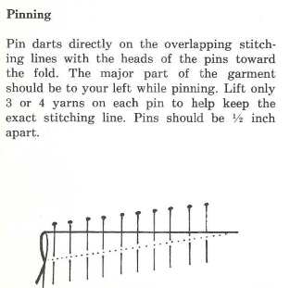
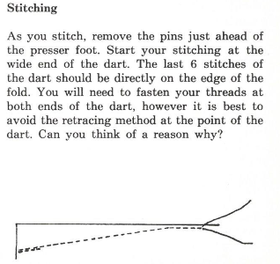
Tie threads at the end
Back stitch at beginning only

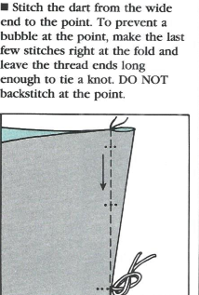

2. Pressing your dart – how to and direction
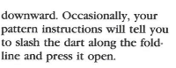
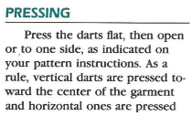

3. Direction of how to press your dart
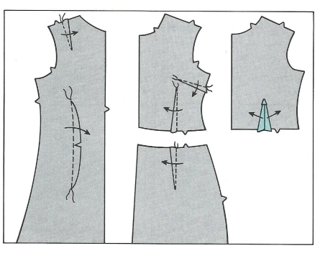
Double Dart – how to sew
Pin your double dart the same way – ensuring that the pins go through the marking lines.
Sewing – start in the middle and sew to one end, exactly like you did in the single dart. Then repeat but sew the other way
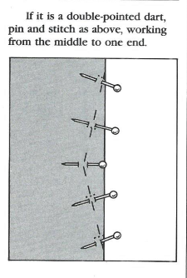
Start in the middle, back stitch and then sew in one direction (black). Then start in the middle again backstitch overtop of the first backstitch and then sew in other direction (blue)
NOTE: You may need to turn your fabric to the other side to sew

