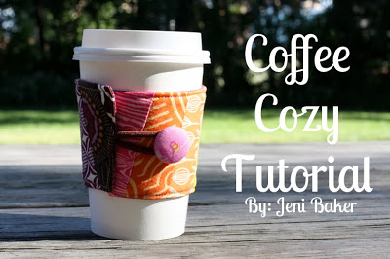
This would be a great addition to a coffee
shop gift card!

Materials for Coffee Cozy
– 4.5″x12″ piece of backing fabric or Fabric scraps from up to 12 different fabrics
– 4.5″x12″ piece of backing fabric – felt is ideal
– 4.5″x12″ piece of fusible fleece or stiff interfacing
– 1 coordinating elastic hair tie
– Small button
– Coordinating thread
Seam Allowance: 1 cm unless noted

How to make a fabric coffee cup cozy

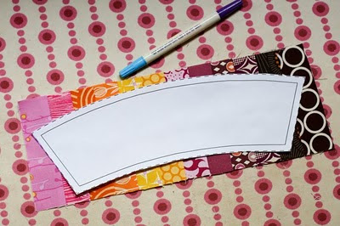
- Using the template, lay it on top of your patchwork, right sides up. Trace using a water soluble pen (just in case!). Cut out and set aside.

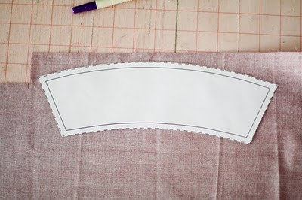
2. Take your lining fabric and place the template on the wrong side of the fabric. Trace and cut out.

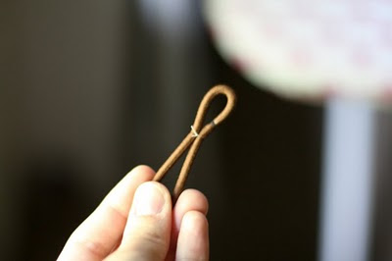
3. Using a small length of thread, fold your hair elastic and tie a
small knot about a 1/3 of the way over, so that you have two uneven
loops. This will help hold it in place when you sew together your
cozy!
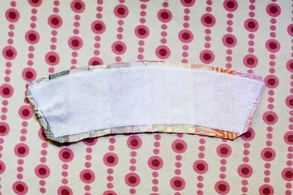
4.Use the interfacing template to cut out your fusible fleece.
Fuse to the wrong side of your outside piece.

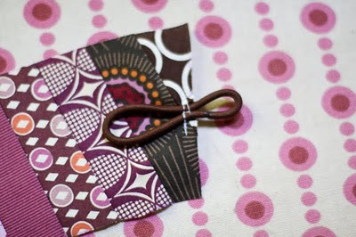
5. Center your hair elastic along one edge of your patchwork piece,with the large loop on the outside piece. Secure with a few stitches with
a 1/8″ seam allowance.

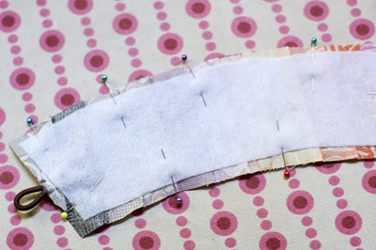
6. Place your front and back pieces right sides together and pin
around the edges.
7. Sew around all four edges, back stitching at the start and finish,
making sure to leave a 1.5″-2″ opening along the bottom edge for turning. Carefully trim the corners and the excess hair elastic.
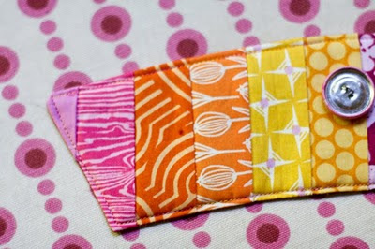
8. Turn your work inside out, using a turning tool (chopstick) or dull pencil to poke out the corners, press. Top stitch very close to the edge,making sure to close up the opening.

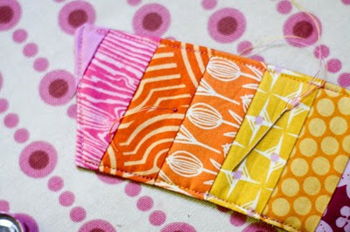
9. On the side opposite the hair tie, center your button 1.5″ from
the short edge. Mark with a pen. Start sewing your button from the
front side, so that you end up with your knot finishing under the
button. This leaves your backing nice and neat!
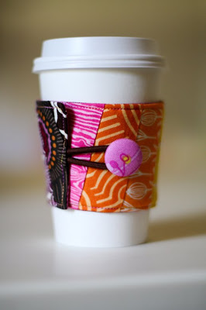
Voila! You’re finished! You could easily make these with more or less
patchwork, or simply, without patchwork!

